AZ-900
Creator: Teiryu Email: teiryu@outlook.com

Question 301 Topic 1
HOTSPOT -
For each of the following statements, select Yes if the statement is true. Otherwise, select No.
NOTE: Each correct selection is worth one point.
Hot Area:
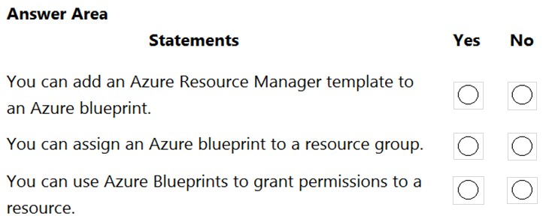

Answer:
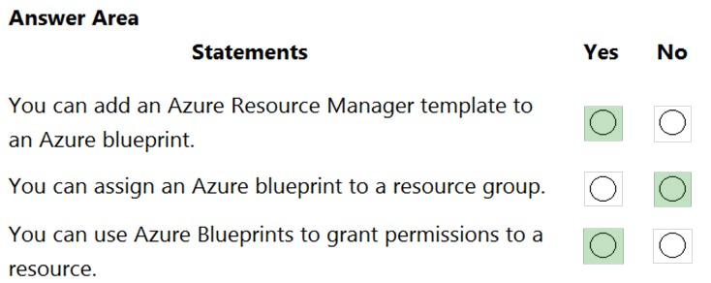

Question 302 Topic 1
HOTSPOT -
For each of the following statements, select Yes if the statement is true. Otherwise, select No.
NOTE: Each correct selection is worth one point.
Hot Area:
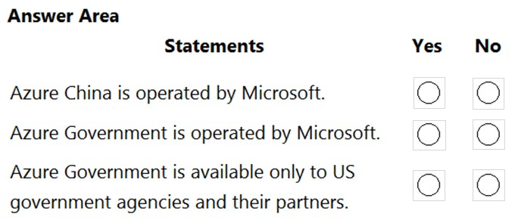

Answer:
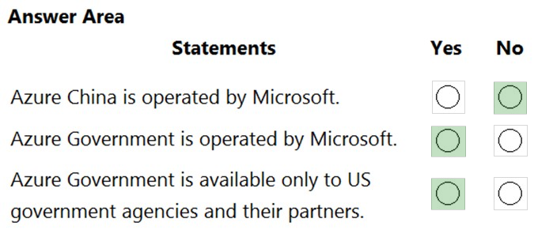

Question 303 Topic 1
HOTSPOT -
For each of the following statements, select Yes if the statement is true. Otherwise, select No.
NOTE: Each correct selection is worth one point.
Hot Area:
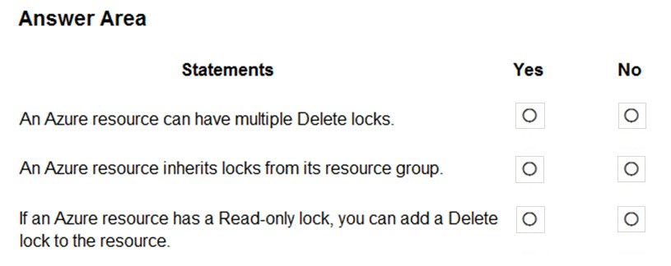

Answer:
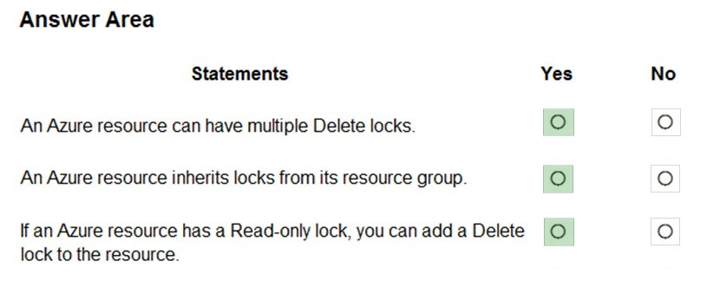

Question 304 Topic 1
Your company plans to migrate all on-premises data to Azure.
You need to identify whether Azure complies with the company's regional requirements.
What should you use?
A. the Knowledge Center
B. Azure Marketplace
C. the MyApps portal
D. the Trust Center
Answer: D
Voted Answer: D

Question 305 Topic 1
HOTSPOT -
For each of the following statements, select Yes if the statement is true. Otherwise, select No.
NOTE: Each correct selection is worth one point.
Hot Area:
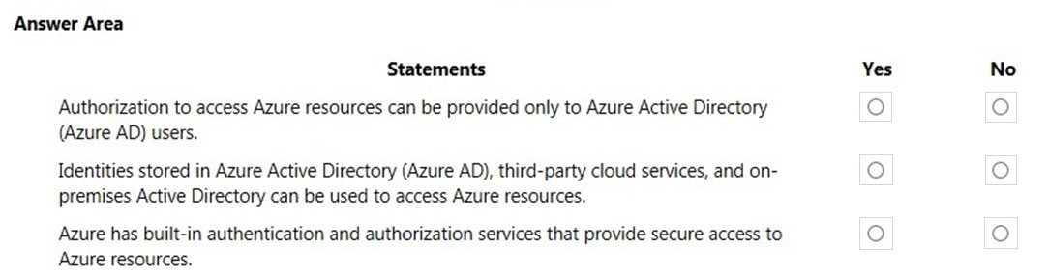

Answer:
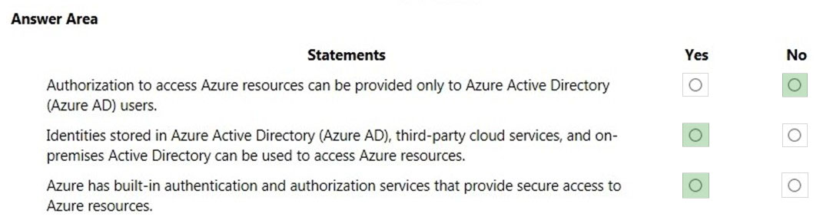

Question 306 Topic 1
HOTSPOT -
To complete the sentence, select the appropriate option in the answer area.
Hot Area:
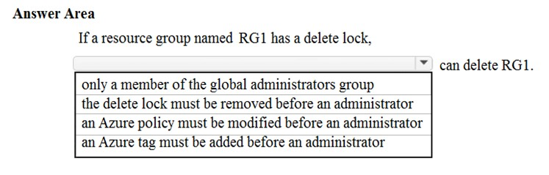

Answer:
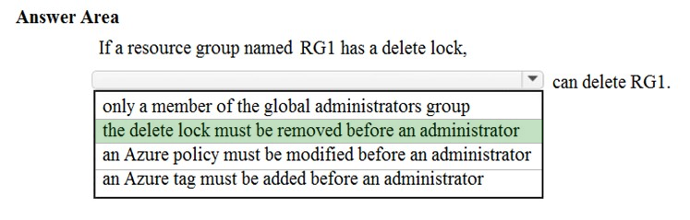

Question 307 Topic 1
HOTSPOT -
Select the answer that correctly completes the sentence.
Hot Area:
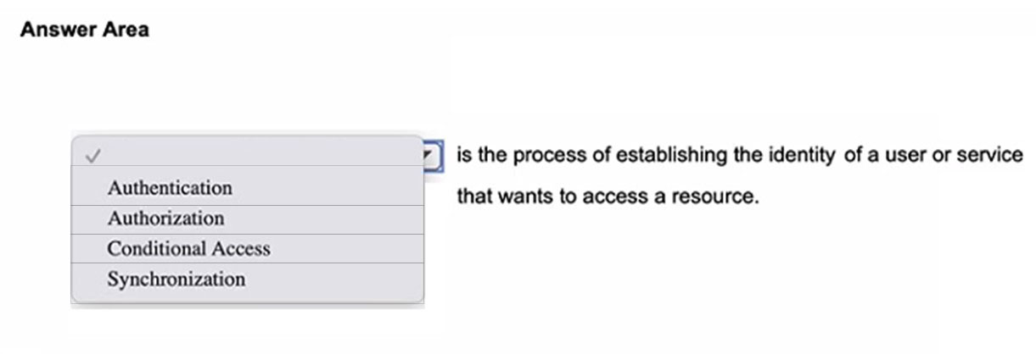

Answer:
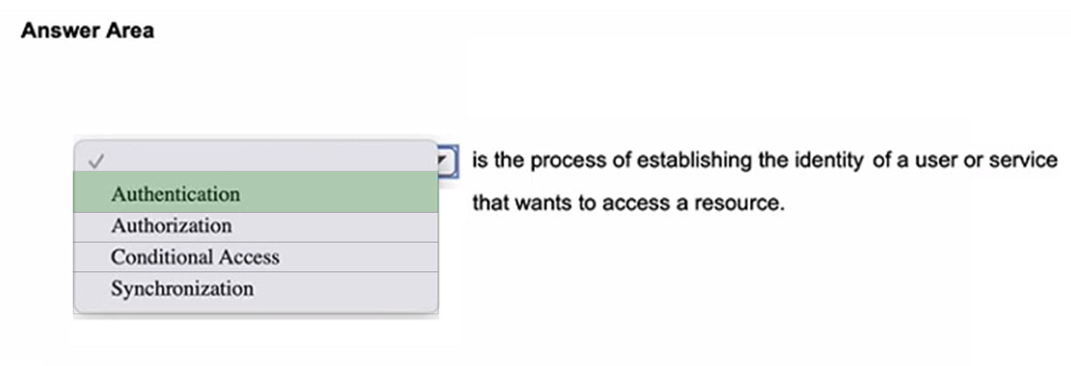

Question 308 Topic 1
HOTSPOT -
For each of the following statements, select Yes if the statement is true. Otherwise, select No.
NOTE: Each correct selection is worth one point.
Hot Area:
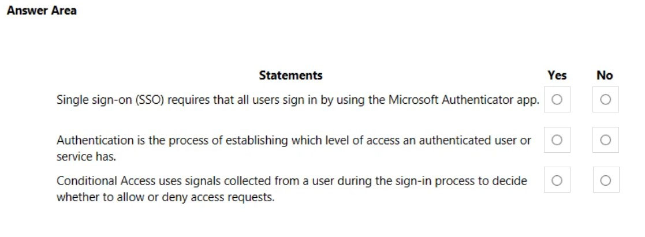

Answer:
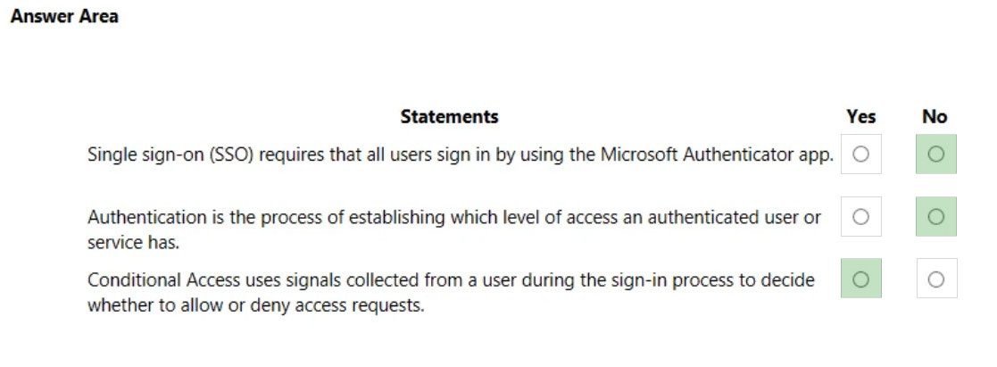

Question 309 Topic 1
What is guaranteed in an Azure Service Level Agreement (SLA) for virtual machines?
A. uptime
B. feature availability
C. bandwidth
D. performance
Answer: A
Voted Answer: A

Question 310 Topic 1
HOTSPOT -
To complete the sentence, select the appropriate option in the answer area.
Hot Area:
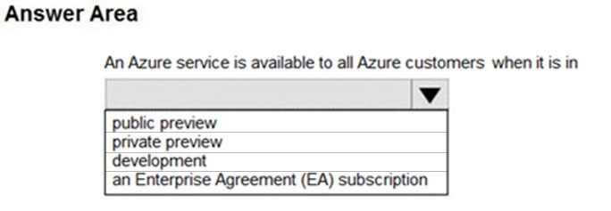

Answer:
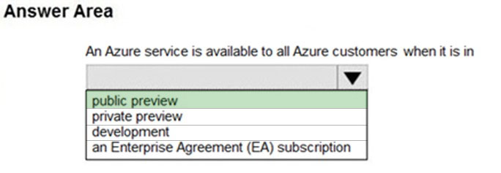

Question 311 Topic 1
Note: This question is part of a series of questions that present the same scenario. Each question in the series contains a unique solution that might meet the stated goals. Some question sets might have more than one correct solution, while others might not have a correct solution.
After you answer a question in this section, you will NOT be able to return to it. As a result, these questions will not appear in the review screen.
Your company plans to purchase an Azure subscription.
The company's support policy states that the Azure environment must provide an option to access support engineers by phone or email.
You need to recommend which support plan meets the support policy requirement.
Solution: Recommend a Basic support plan.
Does this meet the goal?
A. Yes
B. No
Answer: B
Voted Answer: B

Question 312 Topic 1
Note: This question is part of a series of questions that present the same scenario. Each question in the series contains a unique solution that might meet the stated goals. Some question sets might have more than one correct solution, while others might not have a correct solution.
After you answer a question in this section, you will NOT be able to return to it. As a result, these questions will not appear in the review screen.
Your company plans to purchase an Azure subscription.
The company's support policy states that the Azure environment must provide an option to access support engineers by phone or email.
You need to recommend which support plan meets the support policy requirement.
Solution: Recommend a Standard support plan.
Does this meet the goal?
A. Yes
B. No
Answer: A
Voted Answer: A

Question 313 Topic 1
Note: This question is part of a series of questions that present the same scenario. Each question in the series contains a unique solution that might meet the stated goals. Some question sets might have more than one correct solution, while others might not have a correct solution.
After you answer a question in this section, you will NOT be able to return to it. As a result, these questions will not appear in the review screen.
Your company plans to purchase an Azure subscription.
The company's support policy states that the Azure environment must provide an option to access support engineers by phone or email.
You need to recommend which support plan meets the support policy requirement.
Solution: Recommend a Premier support plan.
Does this meet the goal?
A. Yes
B. No
Answer: A

Question 314 Topic 1
Your company plans to request an architectural review of an Azure environment from Microsoft.
The company currently has a Basic support plan.
You need to recommend a new support plan for the company. The solution must minimize costs.
Which support plan should you recommend?
A. Premier
B. Developer
C. Professional Direct
D. Standard
Answer: C
Voted Answer: C

Question 315 Topic 1
HOTSPOT -
For each of the following statements, select Yes if the statement is true. Otherwise, select No.
NOTE: Each correct selection is worth one point.
Hot Area:
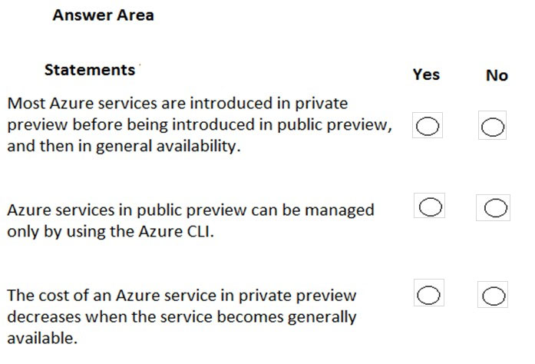

Answer:
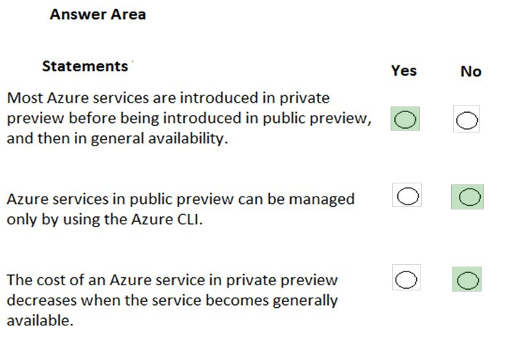

Question 316 Topic 1
What is required to use Azure Cost Management?
A. a Dev/Test subscription
B. Software Assurance
C. an Enterprise Agreement (EA)
D. a pay-as-you-go subscription
Answer: D
Voted Answer: D

Question 317 Topic 1
HOTSPOT -
To complete the sentence, select the appropriate option in the answer area.
Hot Area:
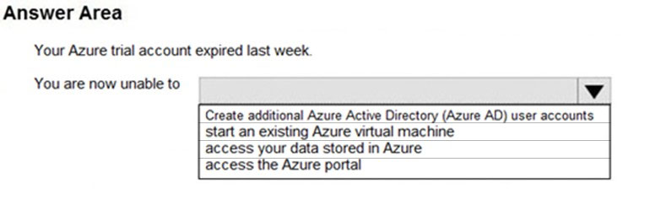

Answer:
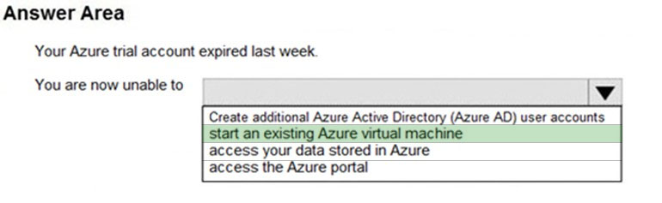

Question 318 Topic 1
Note: This question is part of a series of questions that present the same scenario. Each question in the series contains a unique solution that might meet the stated goals. Some question sets might have more than one correct solution, while others might not have a correct solution.
After you answer a question in this section, you will NOT be able to return to it. As a result, these questions will not appear in the review screen.
Your company plans to purchase an Azure subscription.
The company's support policy states that the Azure environment must provide an option to access support engineers by phone or email.
You need to recommend which support plan meets the support policy requirement.
Solution: Recommend a Professional Direct support plan.
Does this meet the goal?
A. Yes
B. No
Answer: A
Voted Answer: A

Question 319 Topic 1
Your company has a Software Assurance agreement that includes Microsoft SQL Server licenses.
You plan to deploy SQL Server on Azure virtual machines.
What should you do to minimize licensing costs for the deployment?
A. Deallocate the virtual machines during off hours.
B. Use Azure Hybrid Benefit.
C. Configure Azure Cost Management budgets.
D. Use Azure reservations.
Answer: B
Voted Answer: B

Question 320 Topic 1
Your company has 10 departments.
The company plans to implement an Azure environment.
You need to ensure that each department can use a different payment option for the Azure services it consumes.
What should you create for each department?
A. a reservation
B. a subscription
C. a resource group
D. a container instance
Answer: B
Voted Answer: B

Question 321 Topic 1
HOTSPOT -
For each of the following statements, select Yes if the statement is true. Otherwise, select No.
NOTE: Each correct selection is worth one point.
Hot Area:
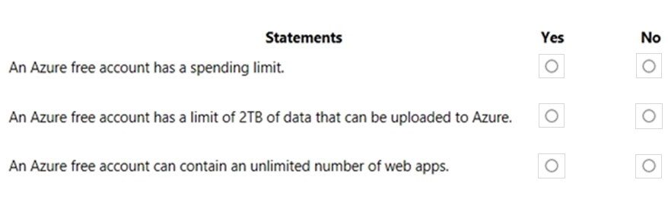

Answer:
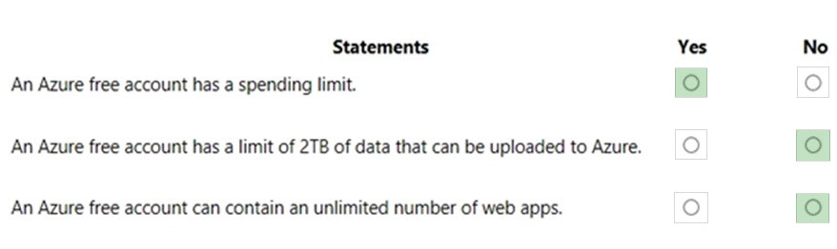

Question 322 Topic 1
HOTSPOT -
For each of the following statements, select Yes if the statement is true. Otherwise, select No.
NOTE: Each correct selection is worth one point.
Hot Area:
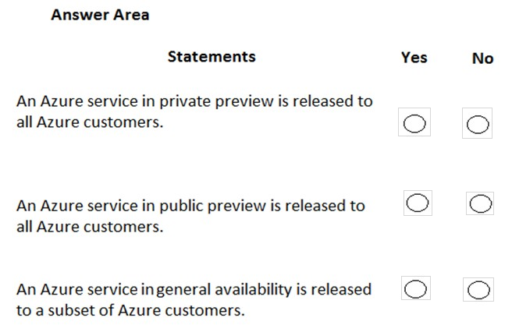

Answer:
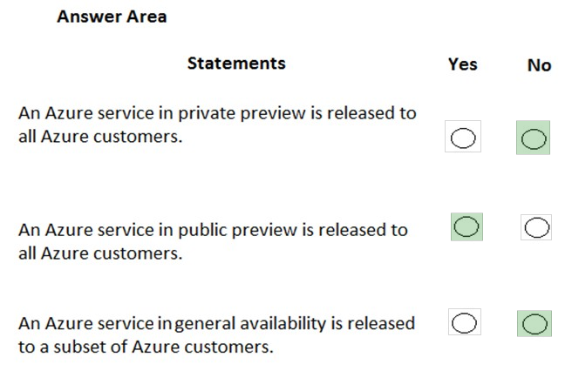

Question 323 Topic 1
HOTSPOT -
For each of the following statements, select Yes if the statement is true. Otherwise, select No.
NOTE: Each correct selection is worth one point.
Hot Area:
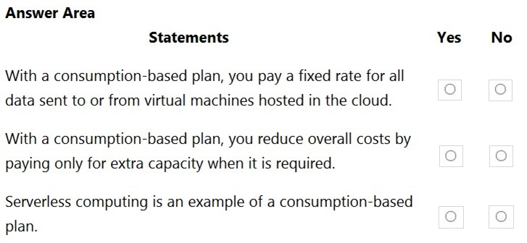

Answer:
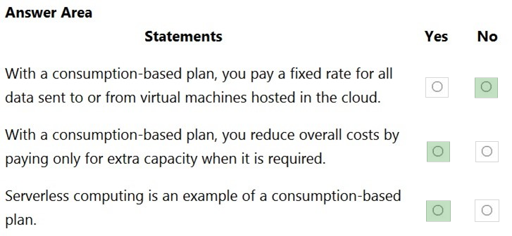

Question 324 Topic 1
HOTSPOT -
For each of the following statements, select Yes if the statement is true. Otherwise, select No.
NOTE: Each correct selection is worth one point.
Hot Area:
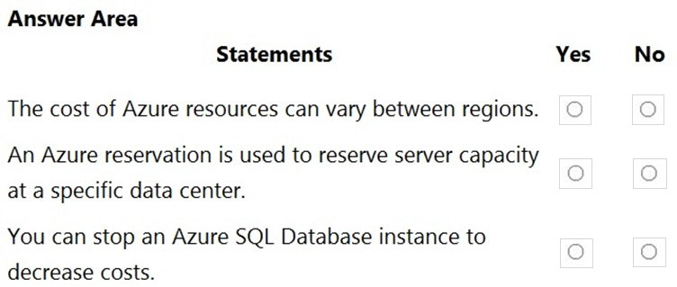

Answer:
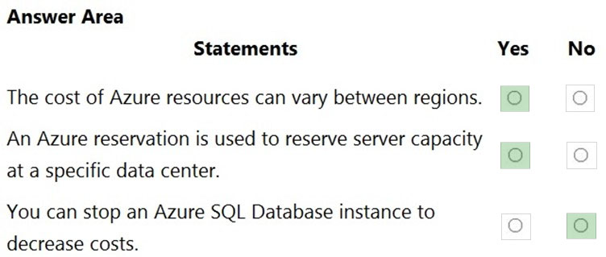

Question 325 Topic 1
HOTSPOT -
To complete the sentence, select the appropriate option in the answer area.
Hot Area:
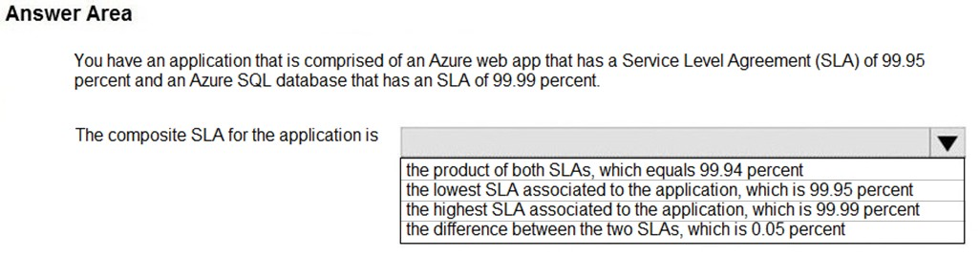

Answer:
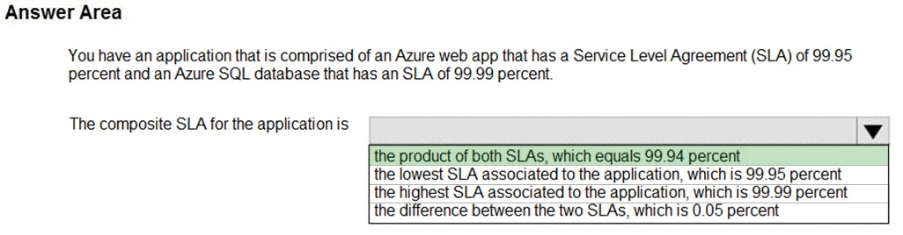

Question 326 Topic 1
HOTSPOT -
For each of the following statements, select Yes if the statement is true. Otherwise, select No.
NOTE: Each correct selection is worth one point.
Hot Area:
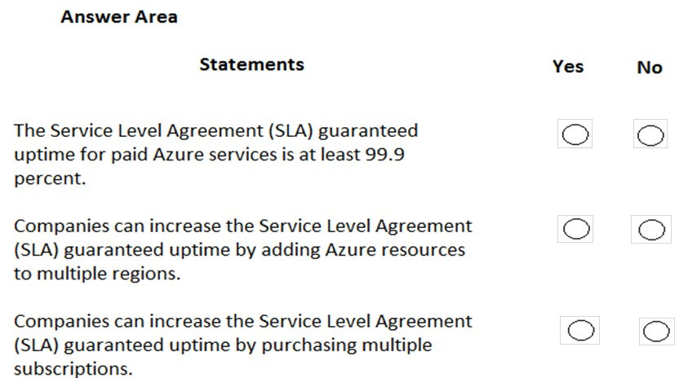

Answer:
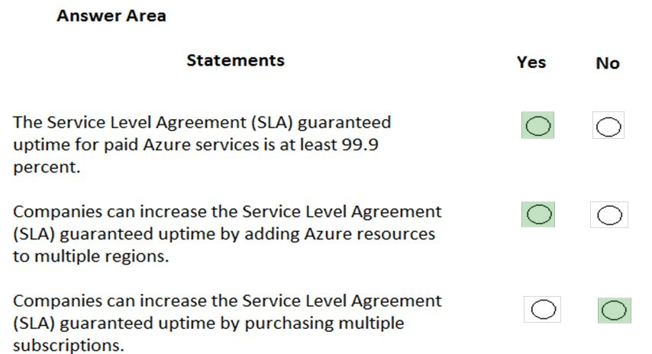

Question 327 Topic 1
Which statement accurately describes the Modern Lifecycle Policy for Azure services?
A. Microsoft provides mainstream support for a service for five years.
B. Microsoft provides a minimum of 12 months' notice before ending support for a service.
C. After a service is made generally available, Microsoft provides support for the service for a minimum of four years.
D. When a service is retired, you can purchase extended support for the service for up to five years.
Answer: B
Voted Answer: B

Question 328 Topic 1
HOTSPOT -
You need to request that Microsoft increase a subscription quota limit for your company.
Which blade should you use from the Azure portal? To answer, select the appropriate blade in the answer area.
Hot Area:
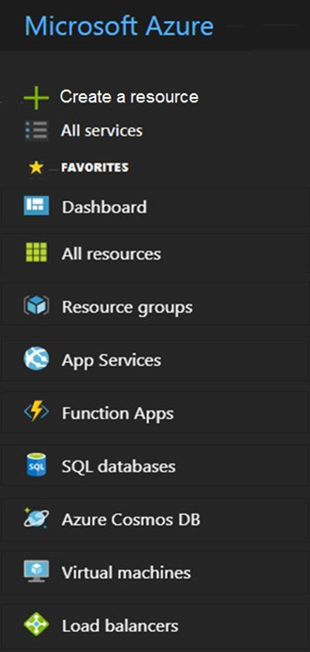

Answer:

Question 329 Topic 1
HOTSPOT -
To complete the sentence, select the appropriate option in the answer area.
Hot Area:
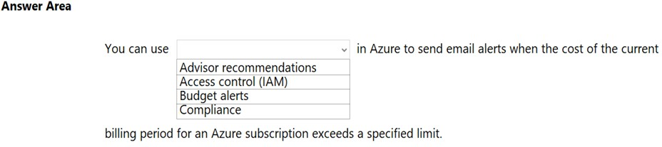

Answer:
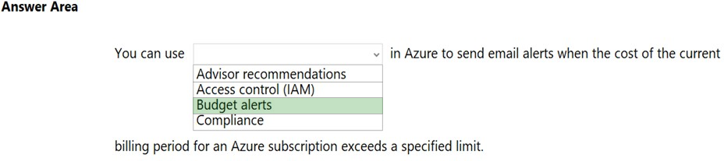

Question 330 Topic 1
HOTSPOT -
For each of the following statements, select Yes if the statement is true. Otherwise, select No.
NOTE: Each correct selection is worth one point.
Hot Area:
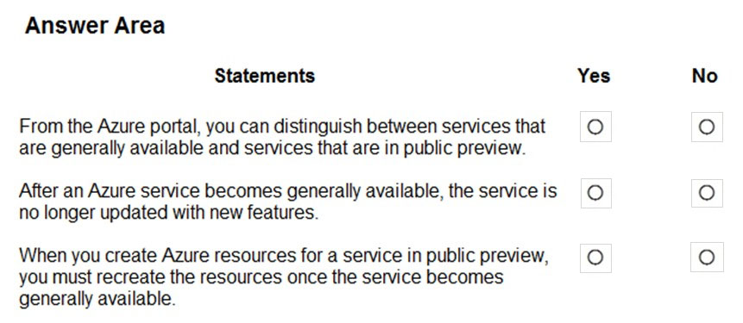

Answer:
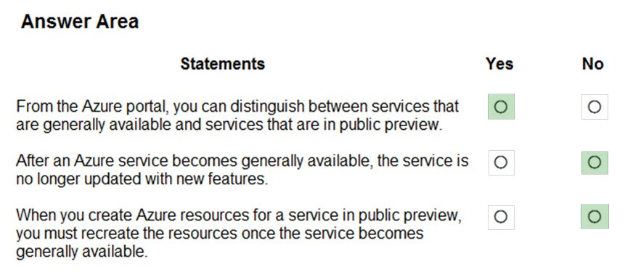

Question 331 Topic 1
HOTSPOT -
For each of the following statements, select Yes if the statement is true. Otherwise, select No.
NOTE: Each correct selection is worth one point.
Hot Area:
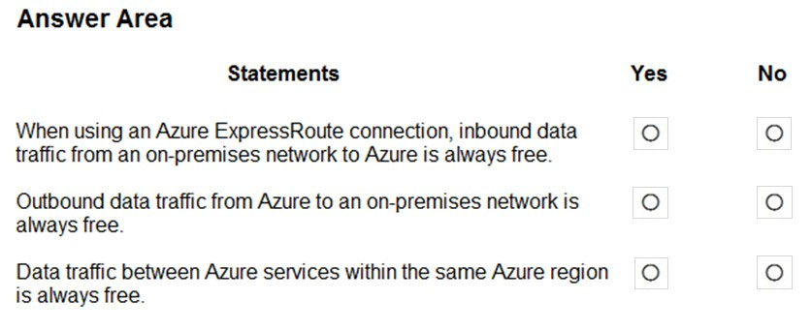

Answer:
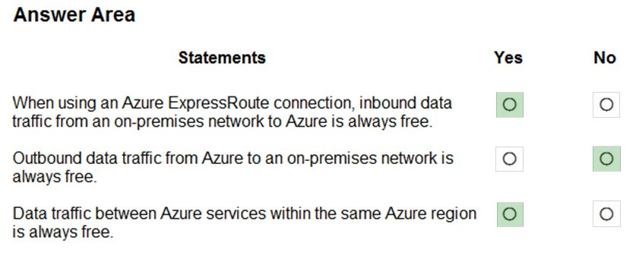

Question 332 Topic 1
Your company has an Azure subscription that contains the following unused resources:
✑ 20 user accounts in Azure Active Directory (Azure AD)
✑ Five groups in Azure AD
✑ 10 public IP addresses
✑ 10 network interfaces
You need to reduce the Azure costs for the company.
Which unused resources should you remove?
A. the network interfaces
B. the public IP addresses
C. the groups
D. the user accounts
Answer: B
Voted Answer: B

Question 333 Topic 1
HOTSPOT -
Select the answer that correctly completes the sentence.
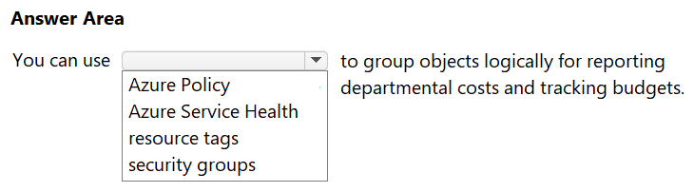
Answer:
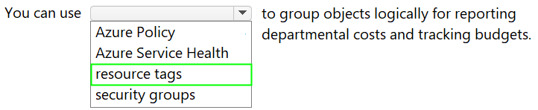

Question 334 Topic 1
HOTSPOT -
For each of the following statements, select Yes if the statement is true. Otherwise, select No.
NOTE: Each correct selection is worth one point.
Hot Area:
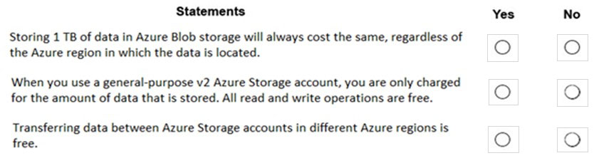

Answer:
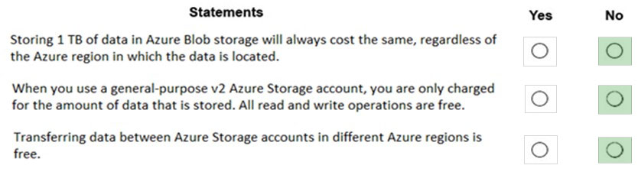

Question 335 Topic 1
HOTSPOT -
For each of the following statements, select Yes if the statement is true. Otherwise, select No.
NOTE: Each correct selection is worth one point.
Hot Area:
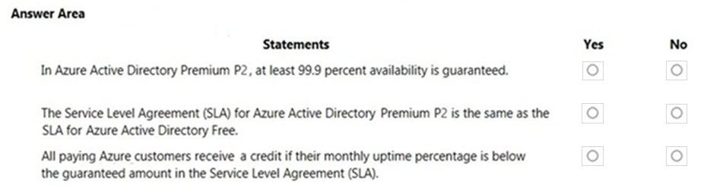

Answer:
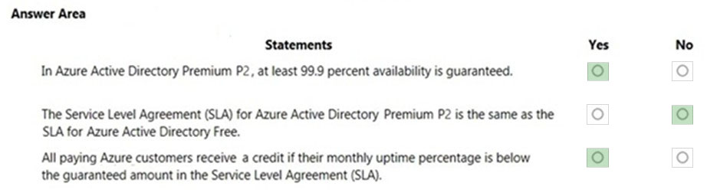

Question 336 Topic 1
HOTSPOT -
For each of the following statements, select Yes if the statement is true. Otherwise, select No.
NOTE: Each correct selection is worth one point.
Hot Area:
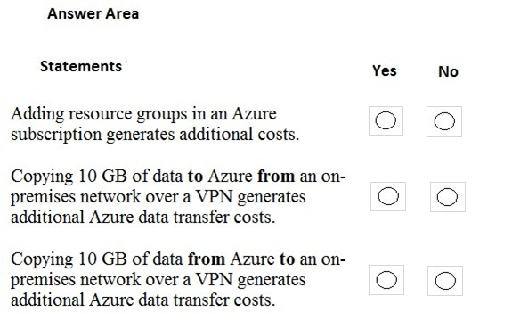

Answer:
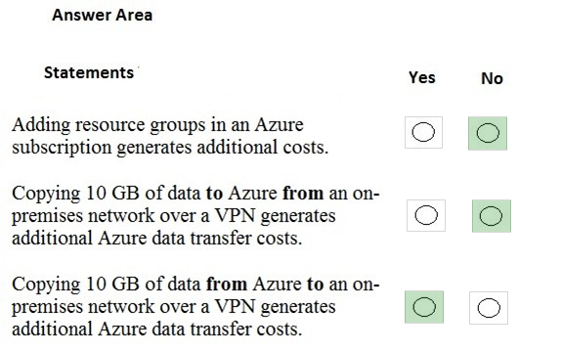

Question 337 Topic 1
Who can use the Azure Total Cost of Ownership (TCO) calculator?
A. billing readers for an Azure subscription only
B. owners for an Azure subscription only
C. anyone
D. all users who have an account in Azure Active Directory (Azure AD) that is linked to an Azure subscription only
Answer: C
Voted Answer: C

Question 338 Topic 1
HOTSPOT -
To complete the sentence, select the appropriate option in the answer area.
Hot Area:
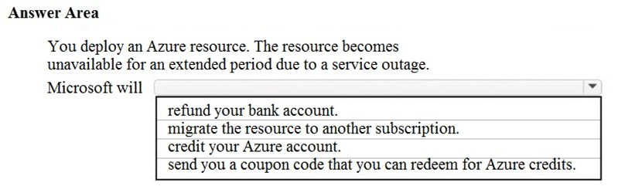

Answer:
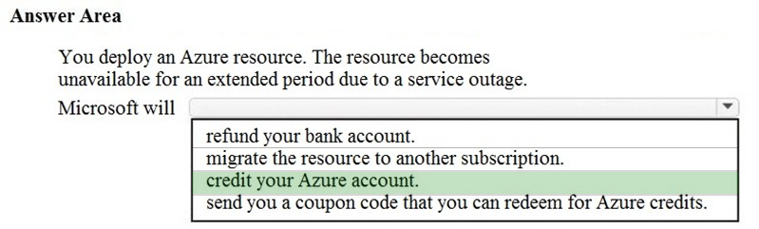

Question 339 Topic 1
Which task can you perform by using Azure Advisor?
A. Integrate Active Directory and Azure Active Directory (Azure AD).
B. Estimate the costs of an Azure solution.
C. Confirm that Azure subscription security follows best practices.
D. Evaluate which on-premises resources can be migrated to Azure.
Answer: C
Voted Answer: C

Question 340 Topic 1
HOTSPOT -
For each of the following statements, select Yes if the statement is true. Otherwise, select No.
NOTE: Each correct selection is worth one point.
Hot Area:
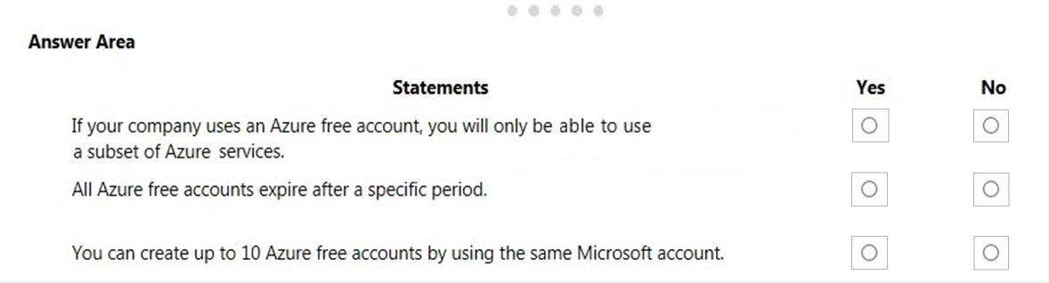

Answer:
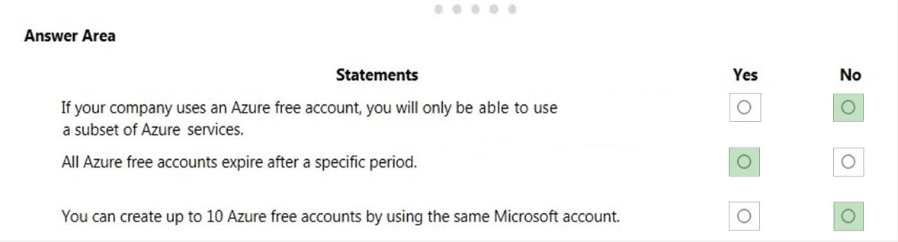

Question 341 Topic 1
You have an Azure application that uses the services shown in the following table.
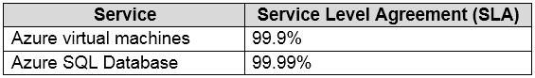
How should you calculate the composite SLA for the application?
A. 0.999 * 0.9999 = 0.9989001 = 99.89001%
B. 0.999 / 0.9999 = 0.9991 = 99.91%
C. Max(0.999, 0.9999) = 0.9999 = 99.99%
D. Min(0.999, 0.9999) = 0.999 = 99.9%
Answer: A
Voted Answer: A

Question 342 Topic 1
HOTSPOT -
Select the answer that correctly completes the sentence.
Hot Area:
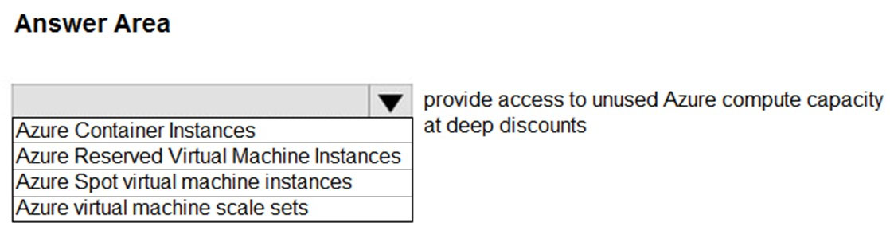

Answer:
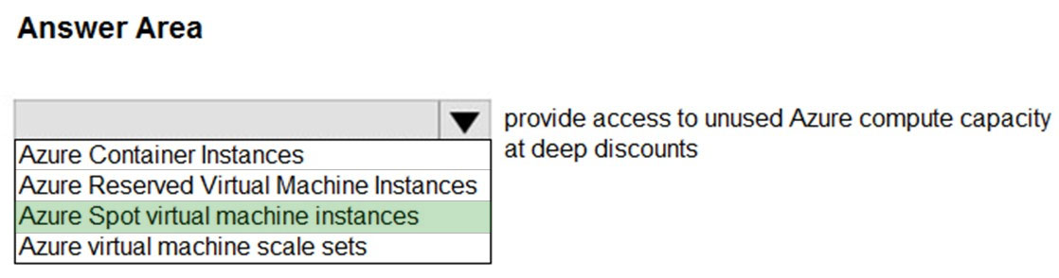

Question 343 Topic 1
HOTSPOT -
Select the answer that correctly completes the sentence.
Hot Area:
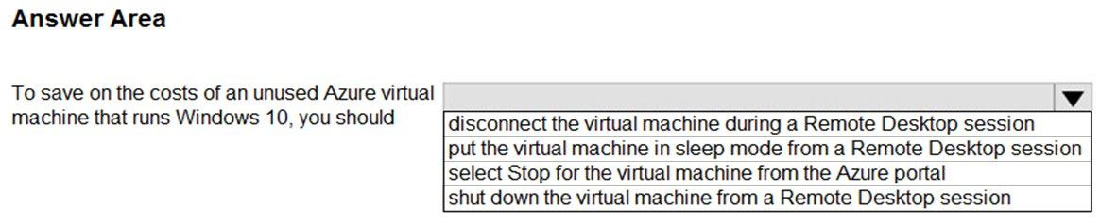

Answer:
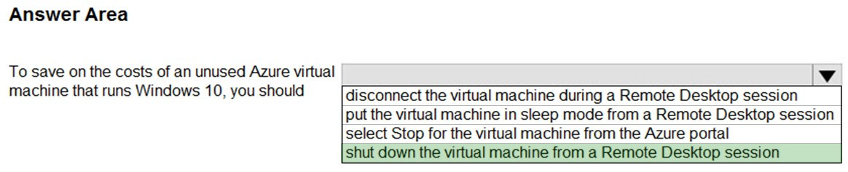

Question 344 Topic 1
HOTSPOT -
Select the answer that correctly completes the sentence.
Hot Area:
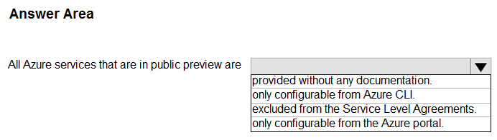

Answer:
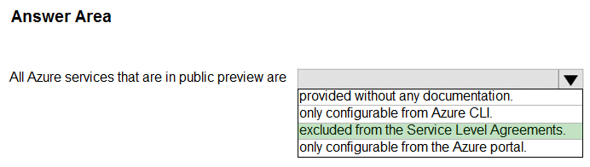

Question 345 Topic 1
HOTSPOT -
Select the answer that correctly completes the sentence.
Hot Area:
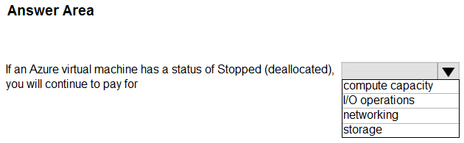

Answer:
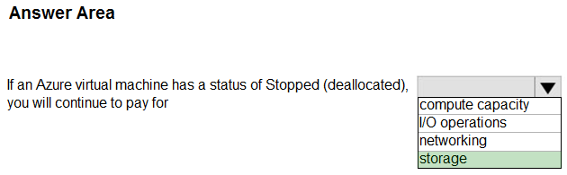

Question 346 Topic 1
HOTSPOT -
Select the answer that correctly completes the sentence.
Hot Area:
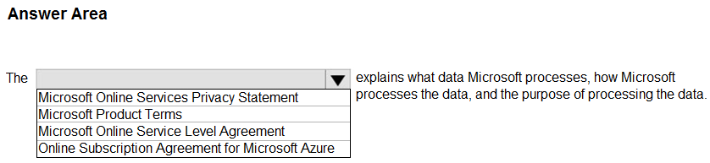

Answer:
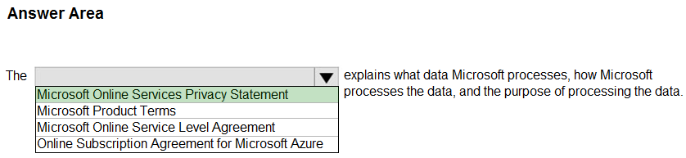

Question 347 Topic 1
HOTSPOT -
Select the answer that correctly completes the sentence.
Hot Area:
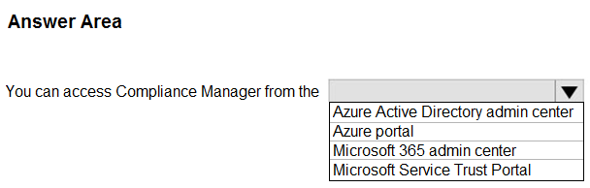

Answer:
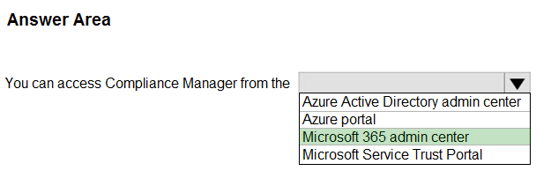

Question 348 Topic 1
DRAG DROP -
Match the Azure compute services to the appropriate descriptions.
To answer, drag the appropriate compute service from the column on the left to its description on the right. Each service may be used once, more than once, or not at all.
NOTE: Each correct match is worth one point.
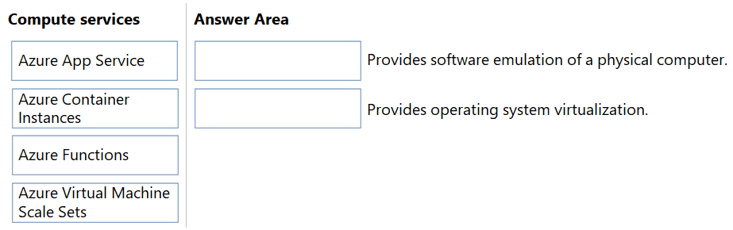
Answer:
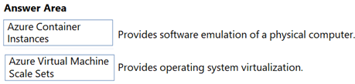

Question 349 Topic 1
HOTSPOT -
Select the answer that correctly completes the sentence.
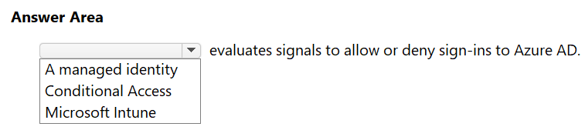
Answer:
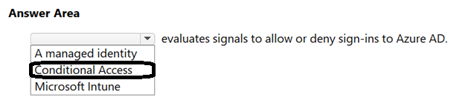

Question 350 Topic 1
HOTSPOT -
For each of the following statements, select Yes if the statement is true. Otherwise, select No.
NOTE: Each correct selection is worth one point.
Hot Area:
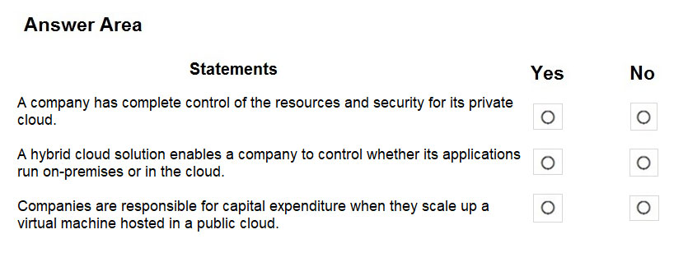

Answer:
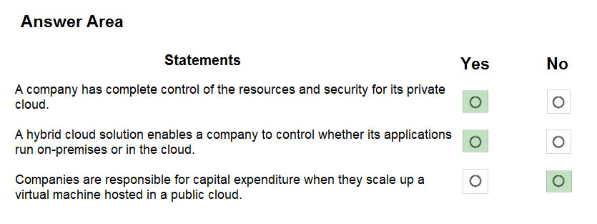

Question 351 Topic 1
Which Service Level Agreement (SLA) is provided for Azure services in public preview?
A. Each service defines its own SLA
B. The SLA will be 99%
C. The SLA will be 1% less than the general availability (GA) SLA
D. The SLA will be 99.95%
Answer: A
Voted Answer: A

Question 352 Topic 1
HOTSPOT -
Select the answer that correctly completes the sentence.
Hot Area:
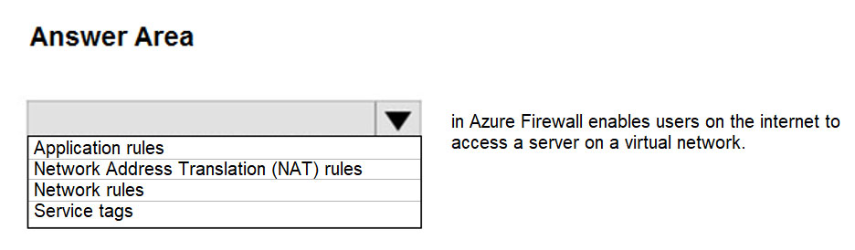

Answer:
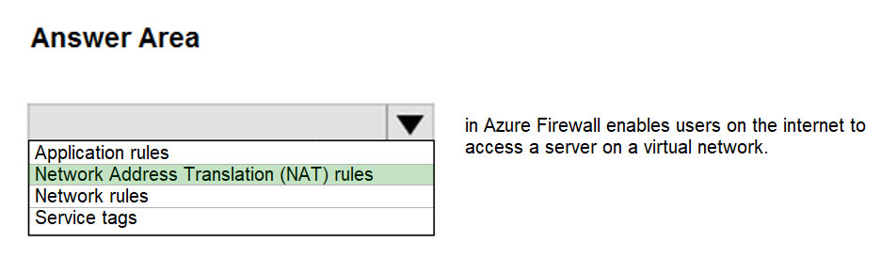

Question 353 Topic 1
HOTSPOT -
For each of the following statements, select Yes if the statement is true. Otherwise, select No.
NOTE: Each correct selection is worth one point.
Hot Area:
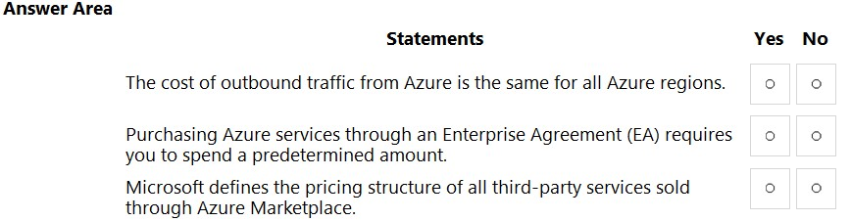

Answer:
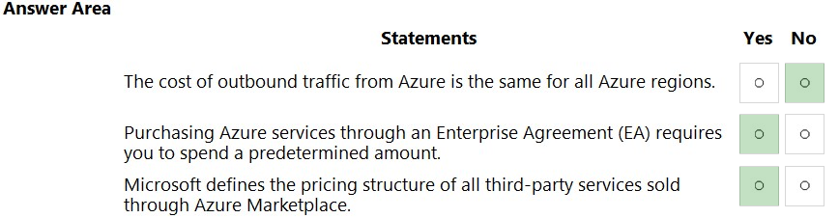

Question 354 Topic 1
HOTSPOT -
For each of the following statements, select Yes if the statement is true. Otherwise, select No.
NOTE: Each correct selection is worth one point.
Hot Area:
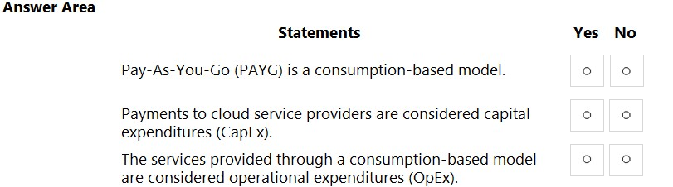

Answer:
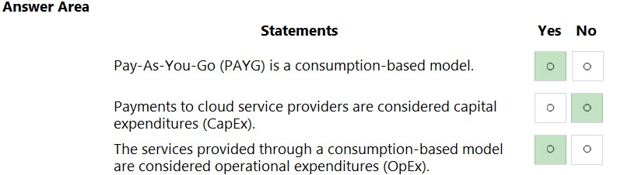

Question 355 Topic 1
What is the longest term you can purchase for Azure Reserved VM instances?
A. one year
B. five years
C. four years
D. three years
Answer: D
Voted Answer: D

Question 356 Topic 1
HOTSPOT -
For each of the following statements, select Yes if the statement is true. Otherwise, select No.
NOTE: Each correct selection is worth one point.
Hot Area:
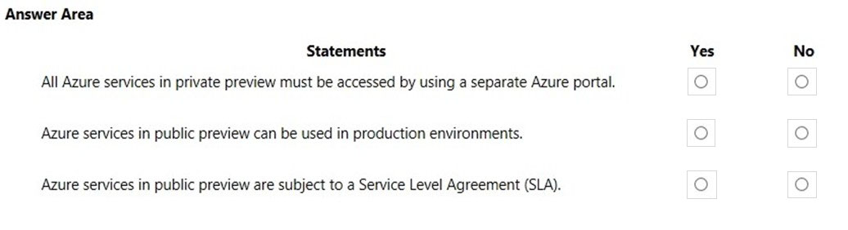

Answer:
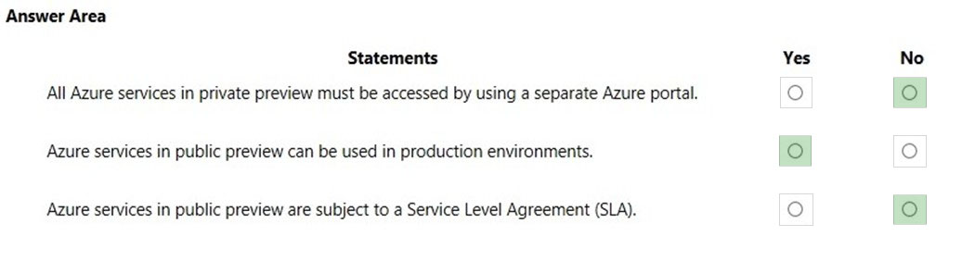

Question 357 Topic 1
Your company has 10 offices. You plan to generate several billing reports from the Azure portal. Each report will contain the Azure resource utilization of each office.
Which Azure Resource Manager feature should you use before you generate the reports?
A. tags
B. templates
C. locks
D. policies
Answer: A
Voted Answer: A

Question 358 Topic 1
HOTSPOT -
For each of the following statements, select Yes if the statement is true. Otherwise, select No.
NOTE: Each correct selection is worth one point.
Hot Area:
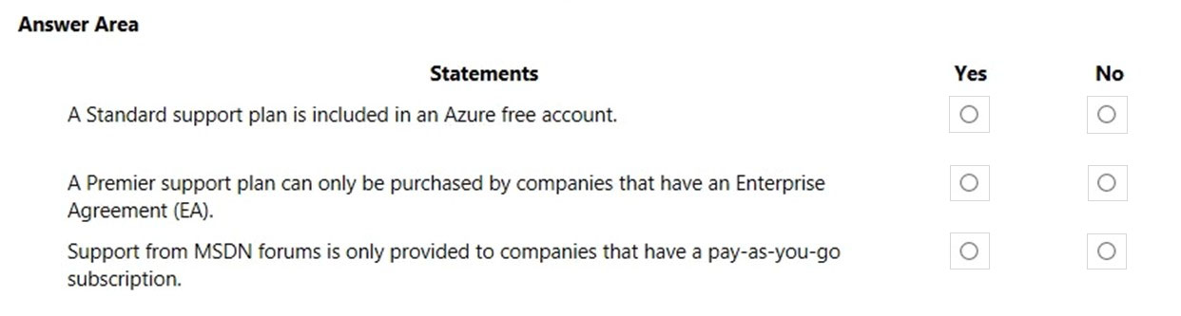

Answer:
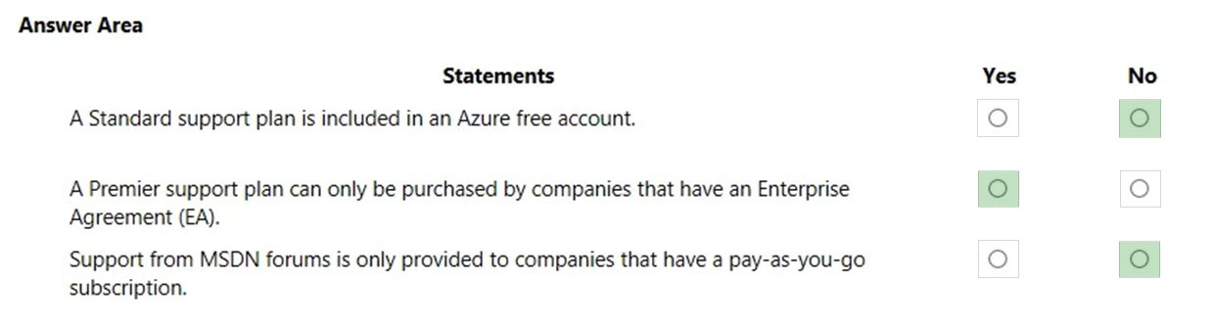

Question 359 Topic 1
This question requires that you evaluate the underlined text to determine if it is correct.
If Microsoft plans to end support for an Azure service that does NOT have a successor service, Microsoft will provide notification at least 12 months before.
Instructions: Review the underlined text. If it makes the statement correct, select `No change is needed`. If the statement is incorrect, select the answer choice that makes the statement correct.
A. No change is needed.
B. 6 months
C. 90 days
D. 30 days
Answer: A
Voted Answer: A

Question 360 Topic 1
HOTSPOT -
For each of the following statements, select Yes if the statement is true. Otherwise, select No.
NOTE: Each correct selection is worth one point.
Hot Area:
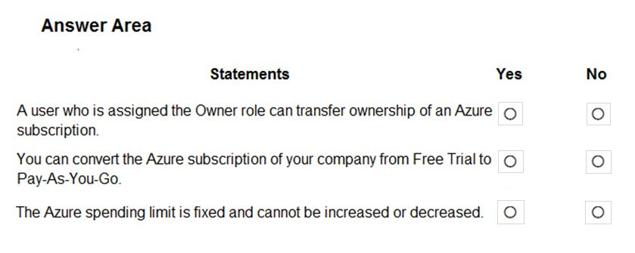

Answer:
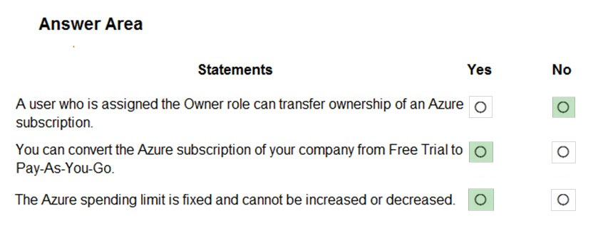

Question 361 Topic 1
HOTSPOT -
For each of the following statements, select Yes if the statement is true. Otherwise, select No.
NOTE: Each correct selection is worth one point.
Hot Area:
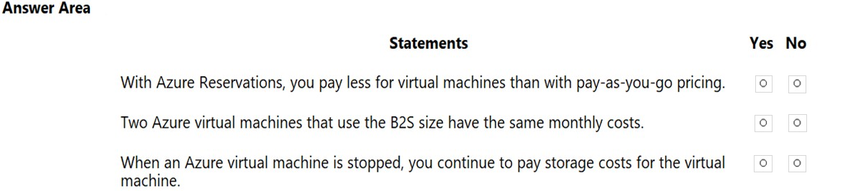

Answer:
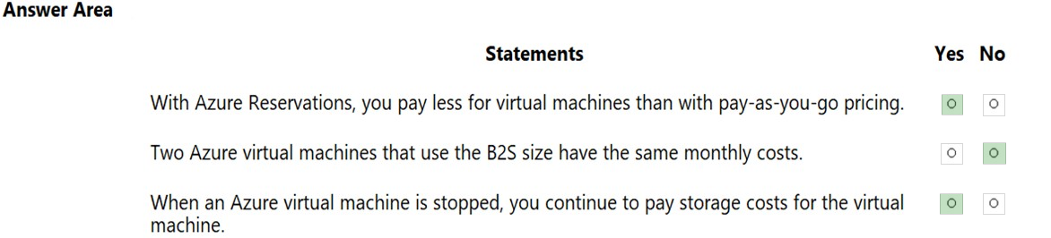

Question 362 Topic 1
Note: This question is part of a series of questions that present the same scenario. Each question in the series contains a unique solution that might meet the stated goals. Some question sets might have more than one correct solution, while others might not have a correct solution.
After you answer a question in this section, you will NOT be able to return to it. As a result, these questions will not appear in the review screen.
Your company has an Azure subscription that contains the following unused resources:
✑ 20 user accounts in Azure Active Directory (Azure AD)
✑ Five groups in Azure AD
✑ 10 public IP addresses
✑ 10 network interfaces
You need to reduce the Azure costs for the company.
Solution: You remove the unused network interfaces.
Does this meet the goal?
A. Yes
B. No
Answer: B
Voted Answer: B

Question 363 Topic 1
Note: This question is part of a series of questions that present the same scenario. Each question in the series contains a unique solution that might meet the stated goals. Some question sets might have more than one correct solution, while others might not have a correct solution.
After you answer a question in this section, you will NOT be able to return to it. As a result, these questions will not appear in the review screen.
Your company has an Azure subscription that contains the following unused resources:
✑ 20 user accounts in Azure Active Directory (Azure AD)
Five groups in Azure AD -
✑ 10 public IP addresses
✑ 10 network interfaces
You need to reduce the Azure costs for the company.
Solution: You remove the unused public IP addresses.
Does this meet the goal?
A. Yes
B. No
Answer: A
Voted Answer: A

Question 364 Topic 1
Note: This question is part of a series of questions that present the same scenario. Each question in the series contains a unique solution that might meet the stated goals. Some question sets might have more than one correct solution, while others might not have a correct solution.
After you answer a question in this section, you will NOT be able to return to it. As a result, these questions will not appear in the review screen.
Your company has an Azure subscription that contains the following unused resources:
✑ 20 user accounts in Azure Active Directory (Azure AD)
✑ Five groups in Azure AD
✑ 10 public IP addresses
✑ 10 network interfaces
You need to reduce the Azure costs for the company.
Solution: You remove the unused user accounts.
Does this meet the goal?
A. Yes
B. No
Answer: B
Voted Answer: B

Question 365 Topic 1
HOTSPOT -
How should you calculate the monthly uptime percentage? To answer, select the appropriate options in the answer area.
NOTE: Each correct selection is worth one point.
Hot Area:
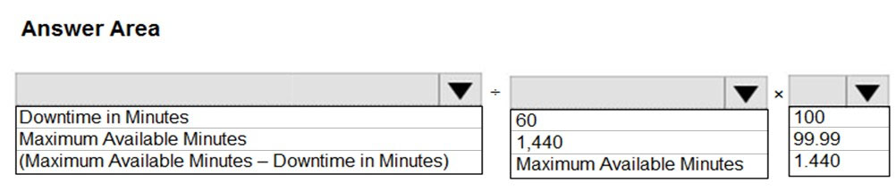

Answer:
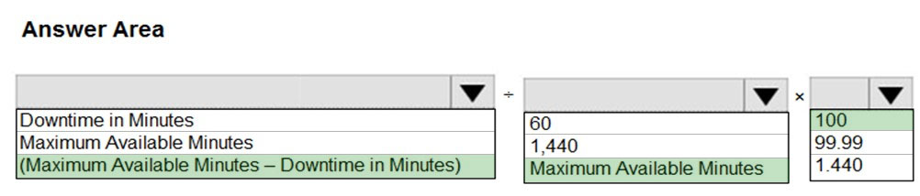

Question 366 Topic 1
HOTSPOT -
For each of the following statements, select Yes if the statement is true. Otherwise, select No.
NOTE: Each correct selection is worth one point.
Hot Area:
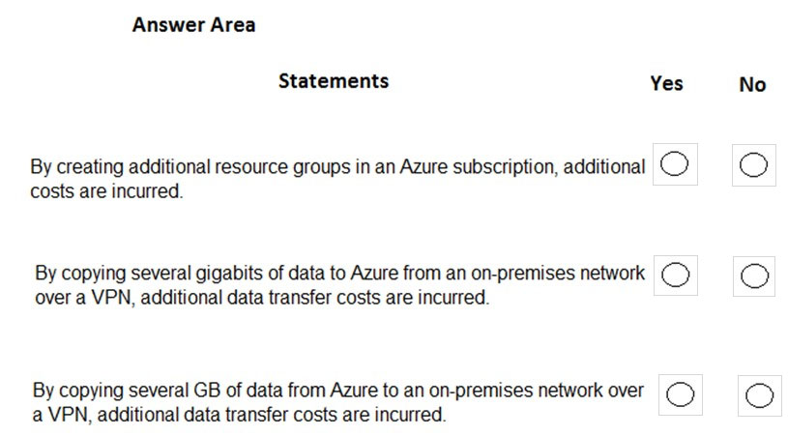

Answer:
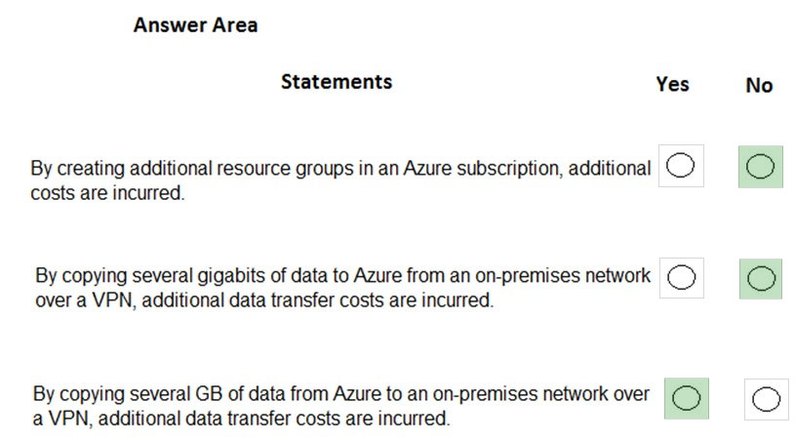

Question 367 Topic 1
This question requires that you evaluate the underlined text to determine if it is correct.
A support plan solution that gives you best practice information, health status and notifications, and 24/7 access to billing information at the lowest possible cost is a Standard support plan.
Instructions: Review the underlined text. If it makes the statement correct, select `No change is needed`. If the statement is incorrect, select the answer choice that makes the statement correct.
A. No change is needed
B. Developer
C. Basic
D. Premier
Answer: C
Voted Answer: C

Question 368 Topic 1
In which Azure support plans can you open a new support request?
A. Premier and Professional Direct only
B. Premier, Professional Direct, and Standard only
C. Premier, Professional Direct, Standard, and Developer only
D. Premier, Professional Direct, Standard, Developer, and Basic
Answer: D
Voted Answer: D

Question 369 Topic 1
This question requires that you evaluate the underlined text to determine if it is correct.
You can create an Azure support request from support.microsoft.com.
Instructions: Review the underlined text. If it makes the statement correct, select `No change is needed.` If the statement is incorrect, select the answer choice that makes the statement correct.
A. No change is needed.
B. the Azure portal
C. the Knowledge Center
D. the Security & Compliance admin center
Answer: B
Voted Answer: B

Question 370 Topic 1
Note: This question is part of a series of questions that present the same scenario. Each question in the series contains a unique solution that might meet the stated goals. Some question sets might have more than one correct solution, while others might not have a correct solution.
After you answer a question in this section, you will NOT be able to return to it. As a result, these questions will not appear in the review screen.
Your company has an Azure subscription that contains the following unused resources:
✑ 20 user accounts in Azure Active Directory (Azure AD)
✑ Five groups in Azure AD
✑ 10 public IP addresses
✑ 10 network interfaces
You need to reduce the Azure costs for the company.
Solution: You remove the unused groups.
Does this meet the goal?
A. Yes
B. No
Answer: B
Voted Answer: B

Question 371 Topic 1
This question requires that you evaluate the underlined text to determine if it is correct.
The Azure Standard support plan is the lowest cost option to receive 24x7 access to support engineers by phone.
Instructions: Review the underlined text. If it makes the statement correct, select `No change is needed`. If the statement is incorrect, select the answer choice that makes the statement correct.
A. No change is needed
B. Developer
C. Basic
D. Professional Direct
Answer: A
Voted Answer: A

Question 372 Topic 1
HOTSPOT -
To complete the sentence, select the appropriate option in the answer area.
Hot Area:
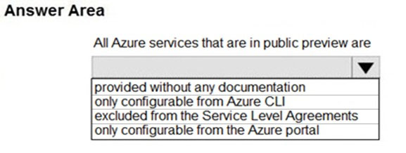

Answer:
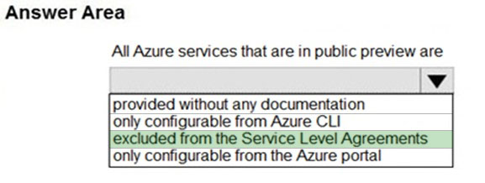

Question 373 Topic 1
HOTSPOT -
For each of the following statements, select Yes if the statement is true. Otherwise, select No.
NOTE: Each correct selection is worth one point.
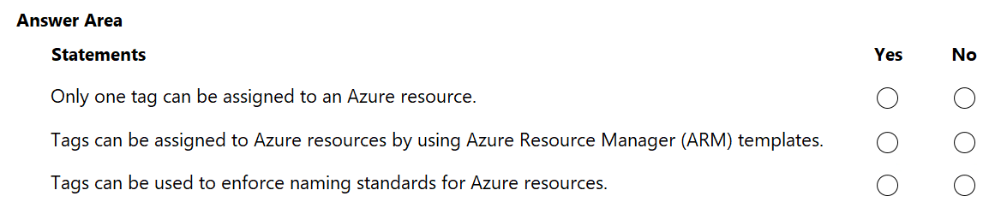
Answer:
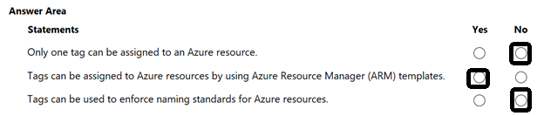

Question 374 Topic 1
You need to compare a company's cloud usage to industry standard best practices.
What should you use?
A. Azure Monitor
B. Azure Service Health
C. Application Insights in Azure Monitor
D. Azure Advisor
Answer: D
Voted Answer: D

Question 375 Topic 1
You need to start Azure Cloud Shell.
What should you use?
A. the Azure portal
B. Azure Command-Line Interface (CLI)
C. Azure PowerShell
D. an Azure Resource Manager (ARM) template
Answer: A
Voted Answer: A

Question 376 Topic 1
How many copies of data are maintained by an Azure Storage account that uses locally-redundant storage (LRS)?
A. 3
B. 4
C. 6
D. 9
Answer: A
Voted Answer: A

Question 377 Topic 1
What enables a cloud service to adapt quickly to changing requirements?
A. high availability
B. predictability
C. manageability
D. agility
Answer: D
Voted Answer: D

Question 378 Topic 1
What is an example of vertical scaling in a cloud environment?
A. adding an additional CPU to an existing Azure virtual machine
B. adding an additional Azure virtual machine
C. adding an additional Azure Virtual Desktop session host
D. adding an additional Azure App Service instance automatically
Answer: A
Voted Answer: A

Question 379 Topic 1
HOTSPOT -
For each of the following statements, select Yes if the statement is true. Otherwise, select No.
NOTE: Each correct selection is worth one point.
Hot Area:
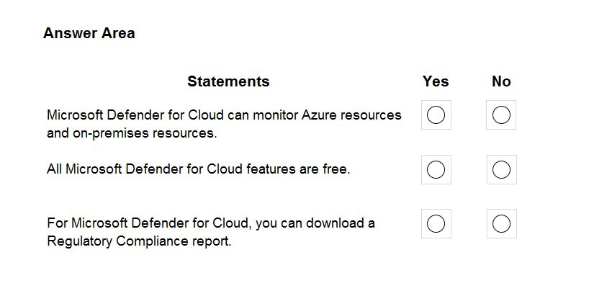

Answer:
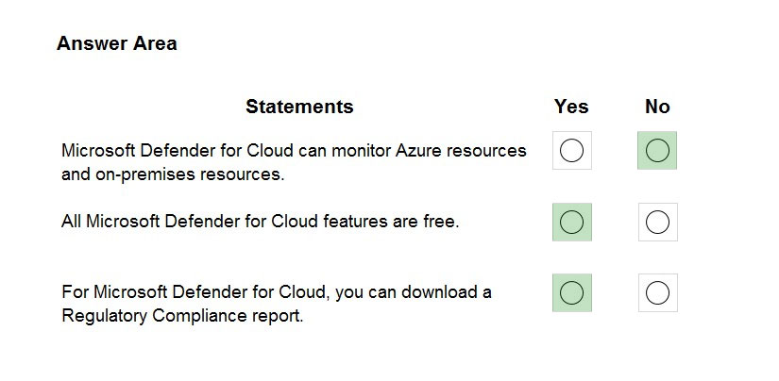

Question 380 Topic 1
HOTSPOT -
For each of the following statements, select Yes if the statement is true. Otherwise, select No.
NOTE: Each correct selection is worth one point.
Hot Area:
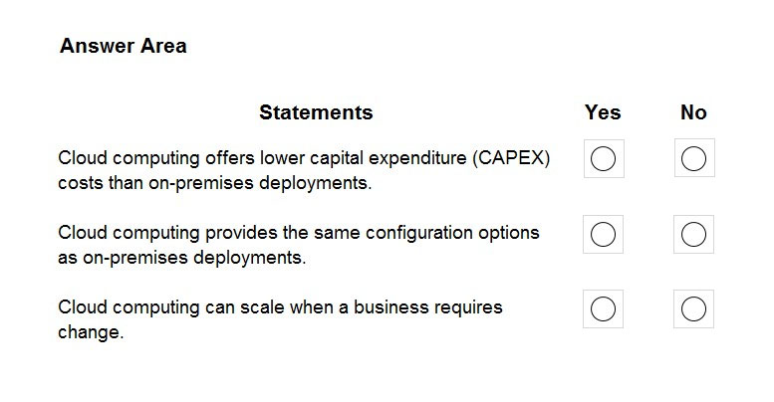

Answer:
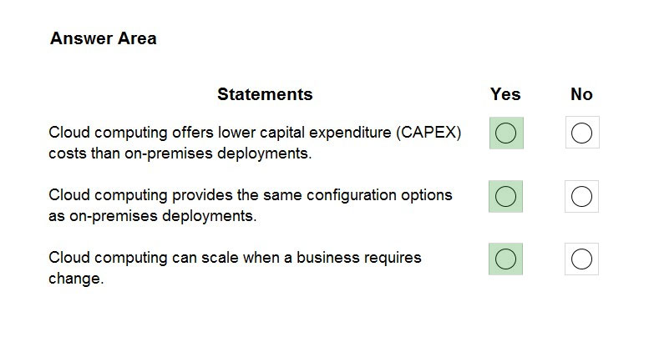

Question 381 Topic 1
What additional resource is required by an Azure virtual machine?
A. a virtual network
B. a service endpoint
C. Azure Firewall
D. a public IP address
Answer: A
Voted Answer: A

Question 382 Topic 1
HOTSPOT -
For each of the following statements, select Yes if the statement is true. Otherwise, select No.
NOTE: Each correct selection is worth one point.
Hot Area:
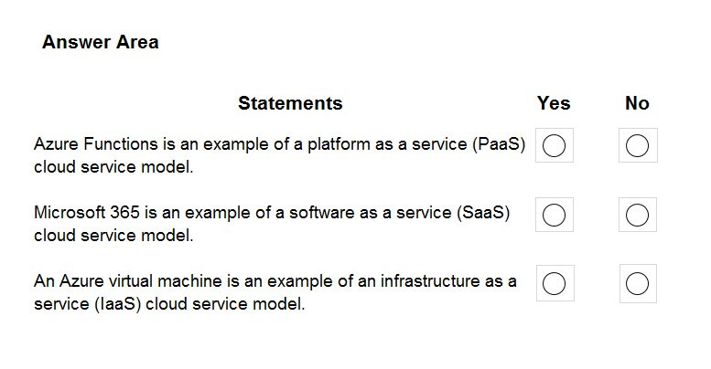

Answer:
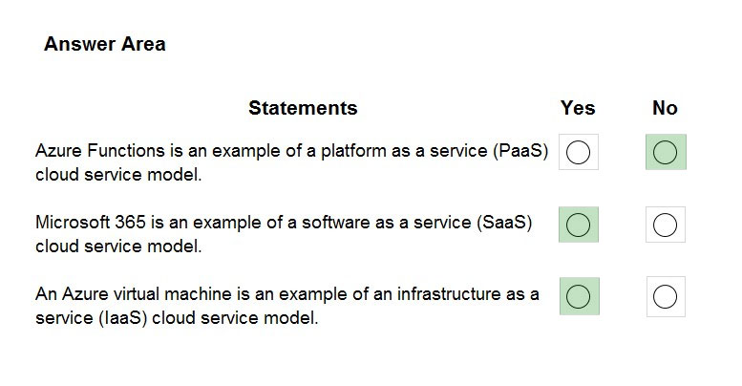

Question 383 Topic 1
How many copies of data are maintained by an Azure Storage account that uses geo-redundant storage (GRS)?
A. 3
B. 4
C. 6
D. 9
Answer: C
Voted Answer: C

Question 384 Topic 1
What is used to grant permission to Azure Virtual Desktop resources?
A. tags
B. role-based access control (RBAC) roles
C. resource groups
D. application security groups
Answer: B
Voted Answer: B

Question 385 Topic 1
HOTSPOT -
For each of the following statements, select Yes if the statement is true. Otherwise, select No.
NOTE: Each correct selection is worth one point.
Hot Area:
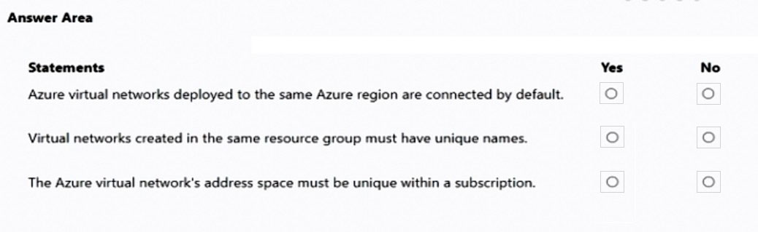

Answer:
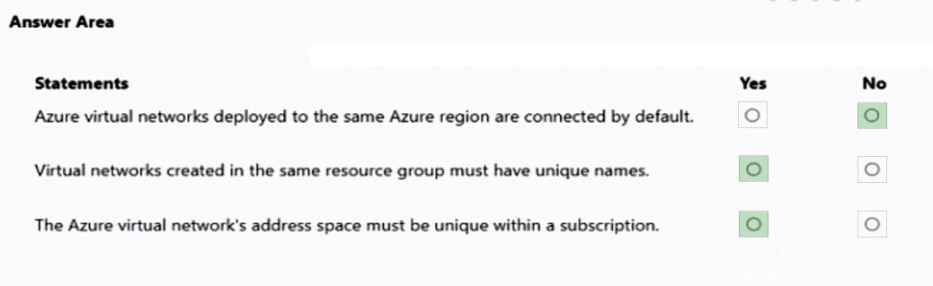

Question 386 Topic 1
DRAG DROP
-
Match the cloud computing benefits to the appropriate requirements.
To answer, drag the appropriate benefit from the column on the left to its requirement on the right. Each benefit may be used once, more than once, or not at all.
NOTE: Each correct match is worth one point.
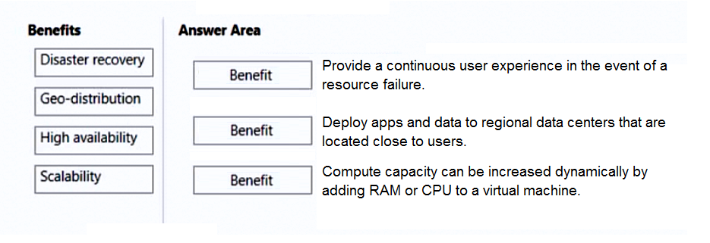
Answer:
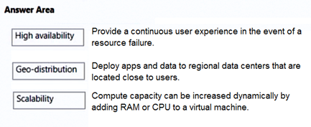

Question 387 Topic 1
DRAG DROP
-
Match the Azure services to the appropriate descriptions.
To answer, drag the appropriate service from the column on the left to its description on the right. Each service may be used once, more than once, or not at all.
NOTE: Each correct match is worth one point.
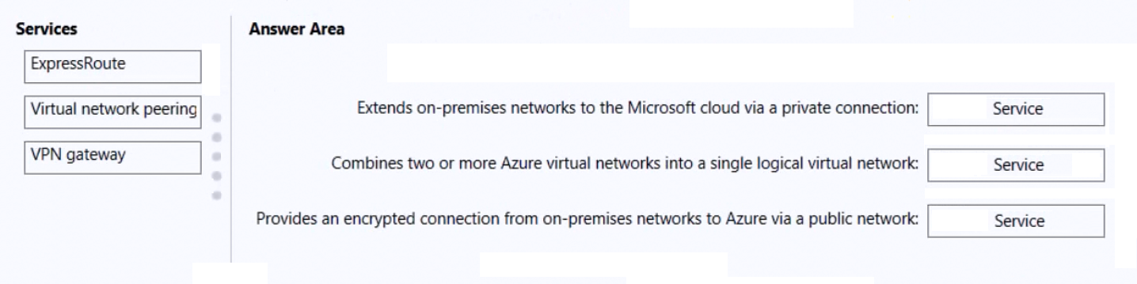
Answer:
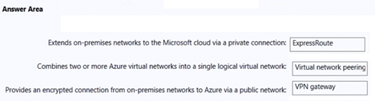

Question 388 Topic 1
HOTSPOT
-
Select the answer that correctly completes the sentence.
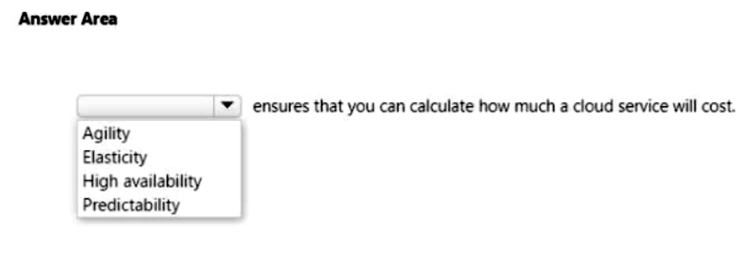
Answer:
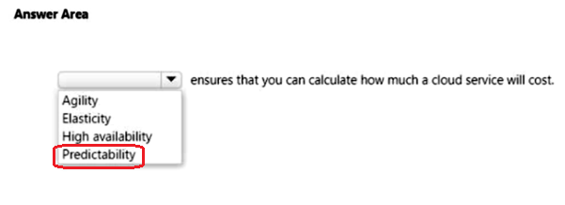

Question 389 Topic 1
Which cloud service model minimizes the management responsibility of a customer?
A. infrastructure as a service (IaaS)
B. platform as a service (PaaS)
C. software as a service (SaaS)
Answer: C
Voted Answer: C

Question 390 Topic 1
DRAG DROP -
You need to identify a customer’s level of shared responsibility based on the cloud service model.
In which order should you list each model from most customer responsibility to least customer responsibility? To answer, move all models from the list of models to the answer area and arrange them in the correct order.
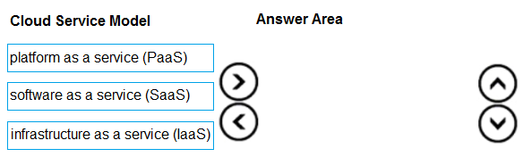
Answer:
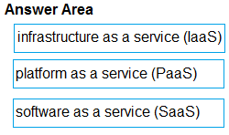

Question 391 Topic 1
HOTSPOT
-
Select the answer that correctly completes the sentence.
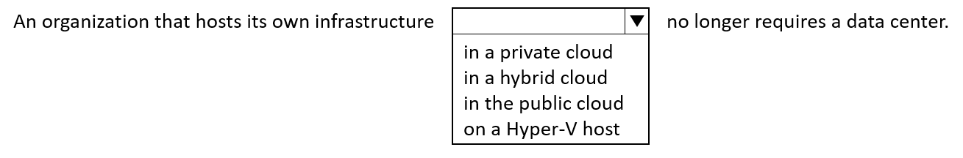
Answer:
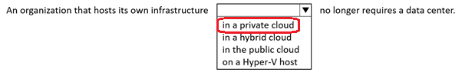

Question 392 Topic 1
HOTSPOT
-
Select the answer that correctly completes the sentence.
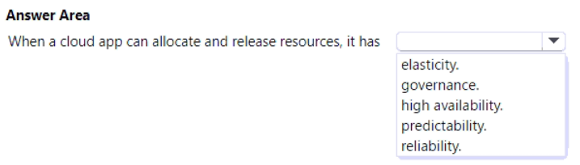
Answer:
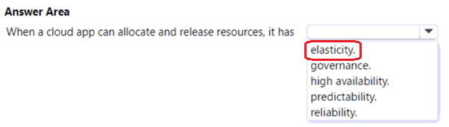

Question 393 Topic 1
HOTSPOT
-
Select the answer that correctly completes the sentence.
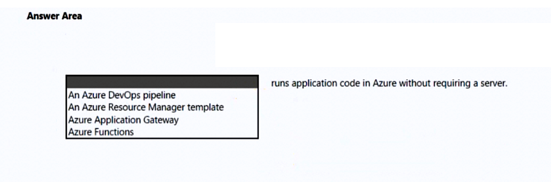
Answer:
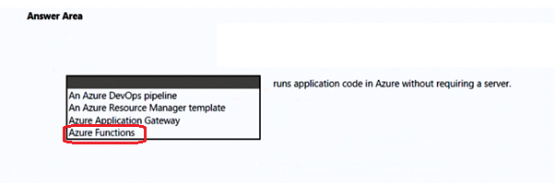

Question 394 Topic 1
HOTSPOT
-
For each of the following statements, select Yes if the statement is true. Otherwise, select No.
NOTE: Each correct selection is worth one point.
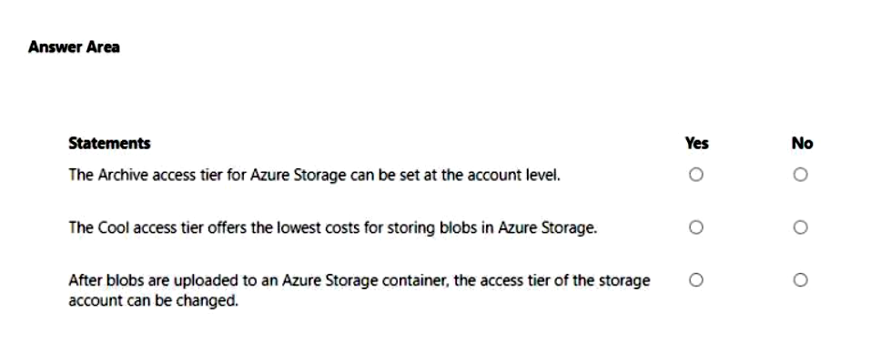
Answer:
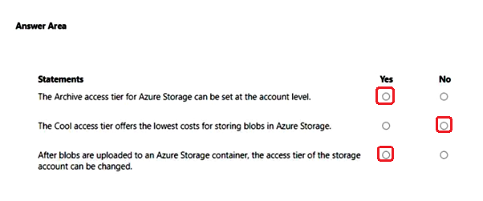

Question 395 Topic 1
DRAG DROP
-
Match the Azure storage services to the appropriate descriptions.
To answer, drag the appropriate storage service from the column on the left to its description on the right. Each service may be used once, more than once, or not at all.
NOTE: Each correct match is worth one point.
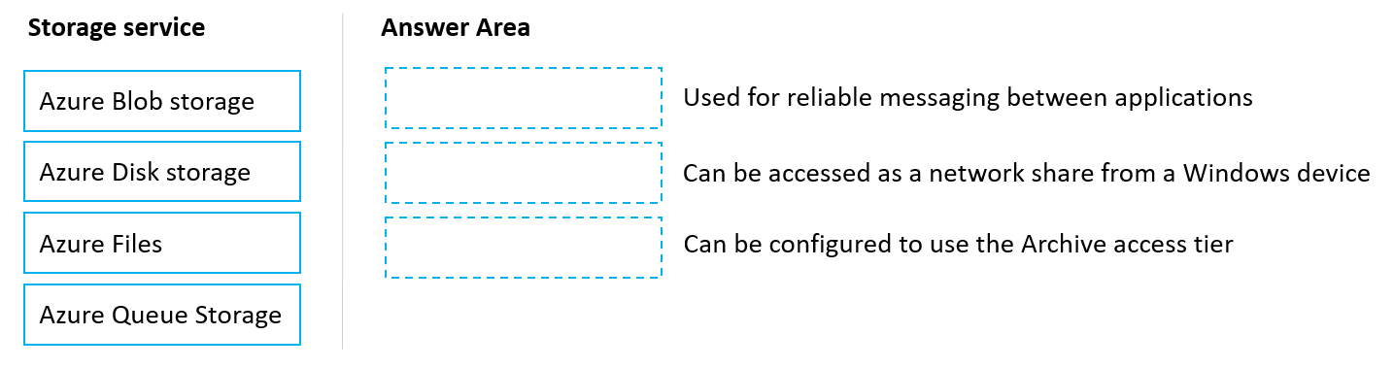
Answer:
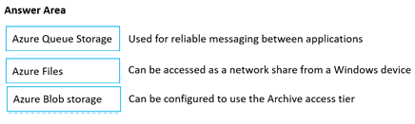

Question 396 Topic 1
HOTSPOT
-
For each of the following statements, select Yes if the statement is true. Otherwise, select No.
NOTE: Each correct selection is worth one point.
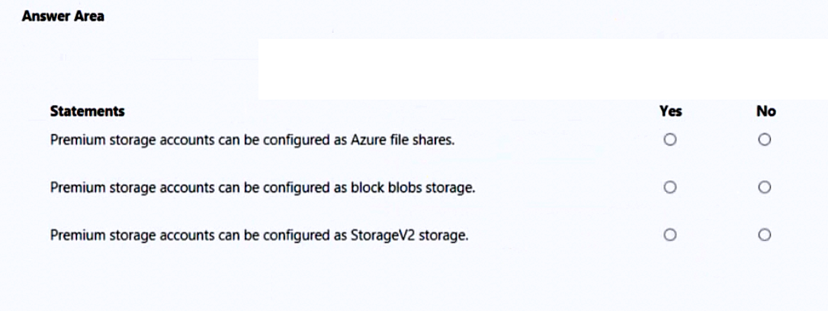
Answer:
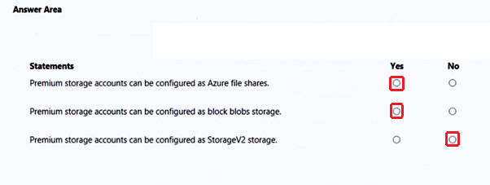

Question 397 Topic 1
HOTSPOT
-
Select the answer that correctly completes the sentence.
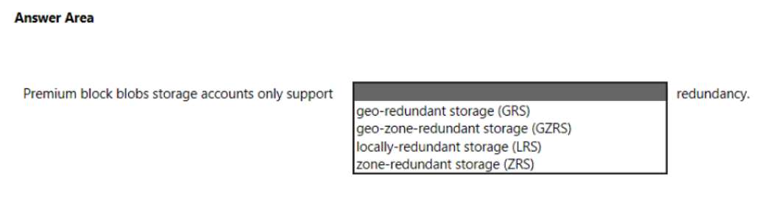
Answer:
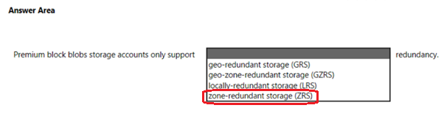

Question 398 Topic 1
You have an Azure web app.
You need to manage the settings of the web app from an iPhone.
What are two Azure management tools that you can use? Each correct answer presents a complete solution.
NOTE: Each correct selection is worth one point.
A. Windows PowerShell
B. Azure Cloud Shell
C. the Azure portal
D. Azure Storage Explorer
Answer: BC
Voted Answer: BC

Question 399 Topic 1
HOTSPOT
-
You need to create a new Azure file share.
What should you use? To answer, select the service in the answer area.
NOTE: Each correct selection is worth one point.
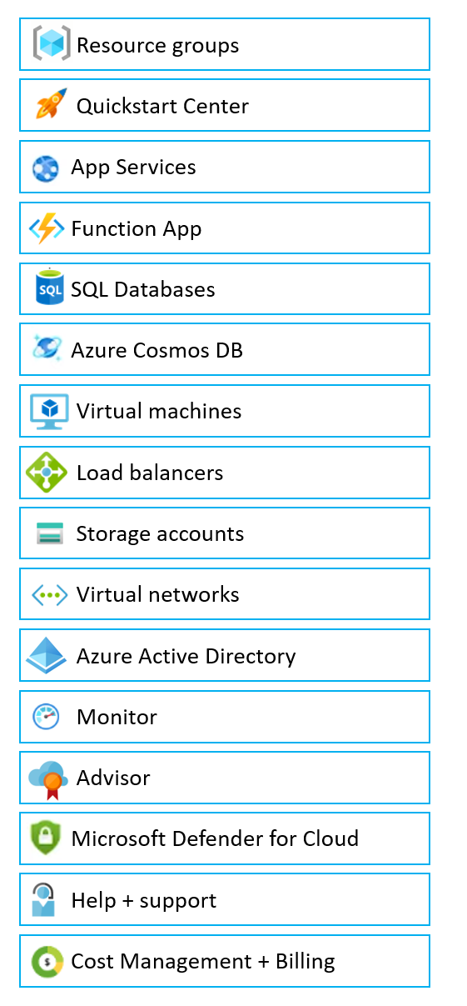
Answer:
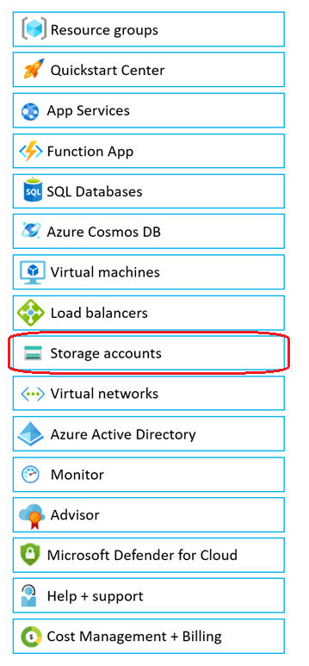

Question 400 Topic 1
HOTSPOT
-
For each of the following statements, select Yes if the statement is true. Otherwise, select No.
NOTE: Each correct selection is worth one point.
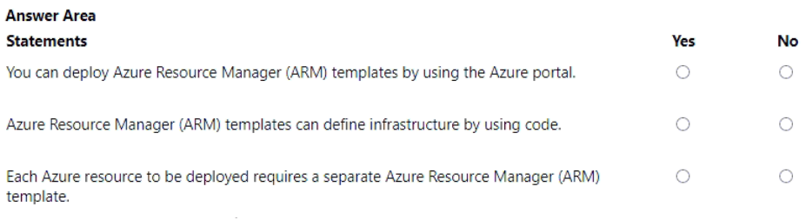
Answer:
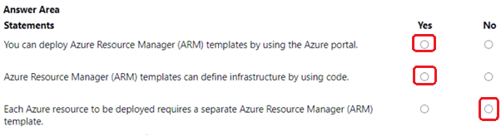

Question 401 Topic 1
What should you use to prevent traffic from an Azure virtual network from being routed to an Azure Storage account via the internet?
A. a network security group (NSG)
B. a public endpoint
C. Azure VPN Gateway
D. a service endpoint
Answer: D
Voted Answer: D

Question 402 Topic 1
Which service can replace a resource lock automatically if the lock is removed?
A. Azure Information Protection (AIP)
B. Azure Blueprints
C. Azure Backup
D. Azure Advisor
Answer: B
Voted Answer: B

Question 403 Topic 1
HOTSPOT
-
You need to create a new user for an Azure subscription.
What should you use? To answer, select the service in the answer area.
NOTE: Each correct match is worth one point.
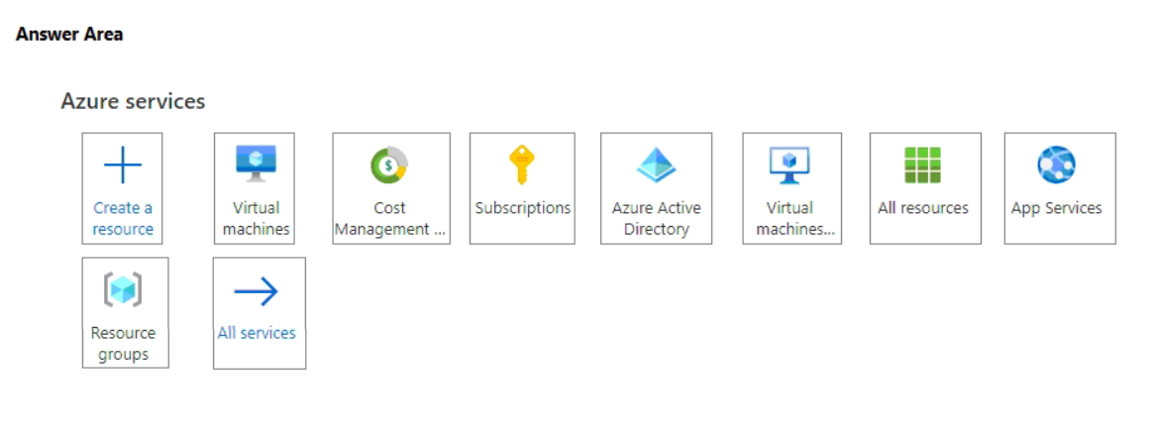
Answer:
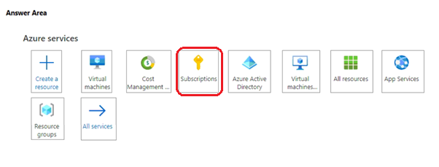

Question 404 Topic 1
HOTSPOT
-
Select the answer that correctly completes the sentence.
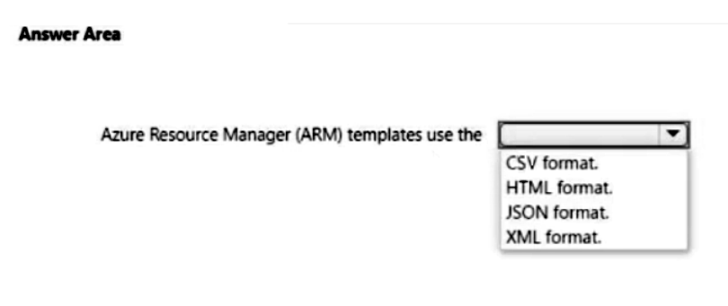
Answer:
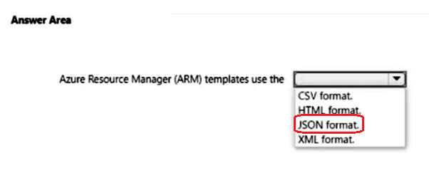

Question 405 Topic 1
You plan to collect and analyze event details for five Azure virtual machines.
You need to run queries to compare the event details collected from all the virtual machines.
Which two tools should you use? Each correct answer presents part of the solution.
NOTE: Each correct selection is worth one point.
A. Azure Service Health
B. Azure Service Bus
C. Azure Monitor
D. Azure Advisor
E. Log Analytics
Answer: CE
Voted Answer: CE

Question 406 Topic 1
HOTSPOT
-
Select the answer that correctly completes the sentence.
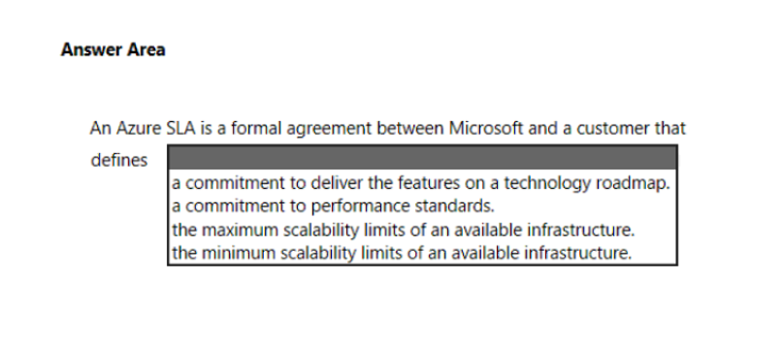
Answer:
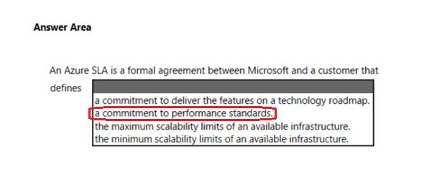

Question 407 Topic 1
What should you use to track the costs of Azure resources?
A. Azure Quickstart templates
B. tags
C. budgets
D. usage and quotas
Answer: C
Voted Answer: C

Question 408 Topic 1
You have an Azure subscription.
You plan to create a virtual machine.
Where will the virtual machine be placed in Azure?
A. In a storage account
B. In a resource group
C. In an administrative unit
D. In an application group
Answer: B
Voted Answer: B

Question 409 Topic 1
You need to migrate an on-premises server by using a lift-and-shift migration.
To which type of cloud service should you migrate?
A. infrastructure as a service (IaaS)
B. software as a service (SaaS)
C. platform as a service (PaaS)
Answer: A
Voted Answer: A

Question 410 Topic 1
HOTSPOT -
Select the answer that correctly completes the sentence.
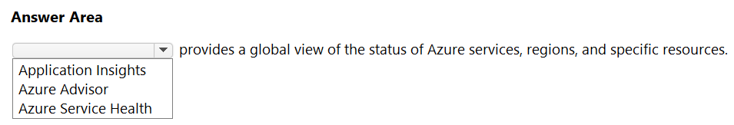
Answer:
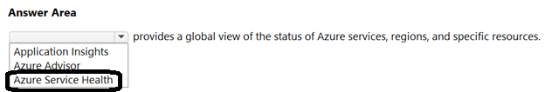

Question 411 Topic 1
You plan to reduce ongoing Azure expenditures.
You need to identify which factors affect the costs of a resource.
Which three factors should you identify? Each correct answer presents a complete solution.
NOTE: Each correct selection is worth one point.
A. the volume of outbound data
B. the volume of inbound data
C. the service tier
D. the Azure region
E. the type of processed data
Answer: ACD
Voted Answer: ACD

Question 412 Topic 1
Your company has an Azure subscription that contains several resources.
You need to identify which department is responsible for the cost of each resource.
What should you use?
A. budgets
B. alerts
C. tags
Answer: C
Voted Answer: C

Question 413 Topic 1
HOTSPOT
-
Select the answer that correctly completes the sentence.
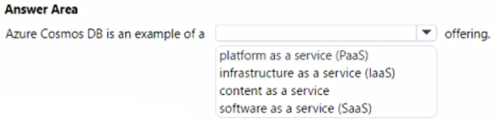
Answer:
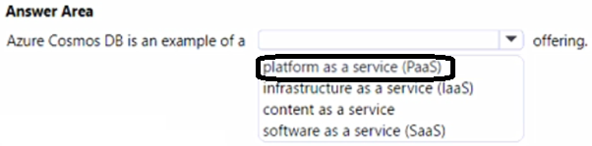

Question 414 Topic 1
HOTSPOT
-
Select the answer that correctly completes the sentence.
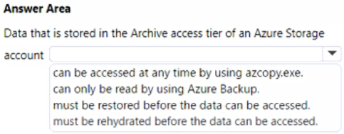
Answer:
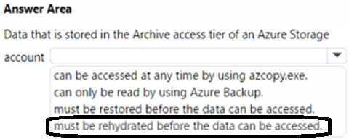

Question 415 Topic 1
HOTSPOT
-
For each of the following statements, select Yes if the statement is true. Otherwise, select No.
NOTE: Each correct selection is worth one point.
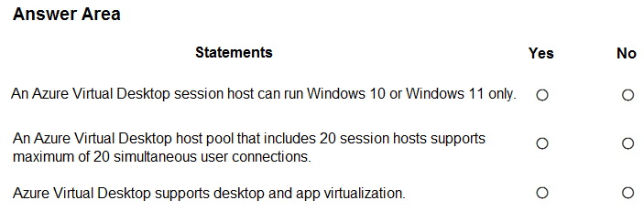
Answer:
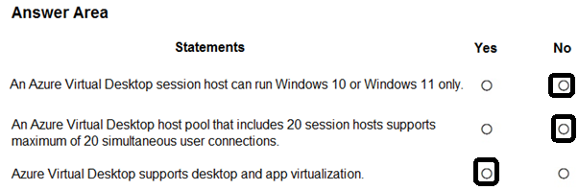

Question 416 Topic 1
HOTSPOT
-
For each of the following statements, select Yes if the statement is true. Otherwise, select No.
NOTE: Each correct selection is worth one point.
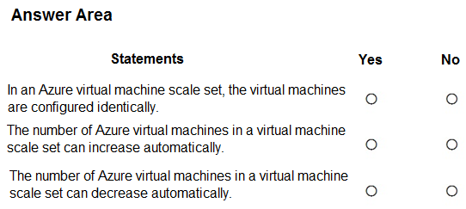
Answer:
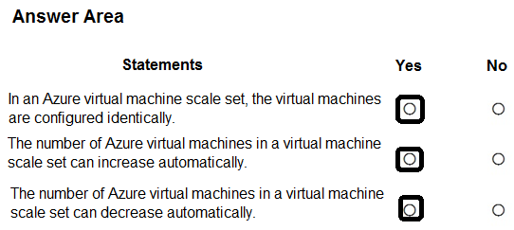

Question 417 Topic 1
HOTSPOT -
For each of the following statements, select Yes if the statement is true. Otherwise, select No.
NOTE: Each correct selection is worth one point.
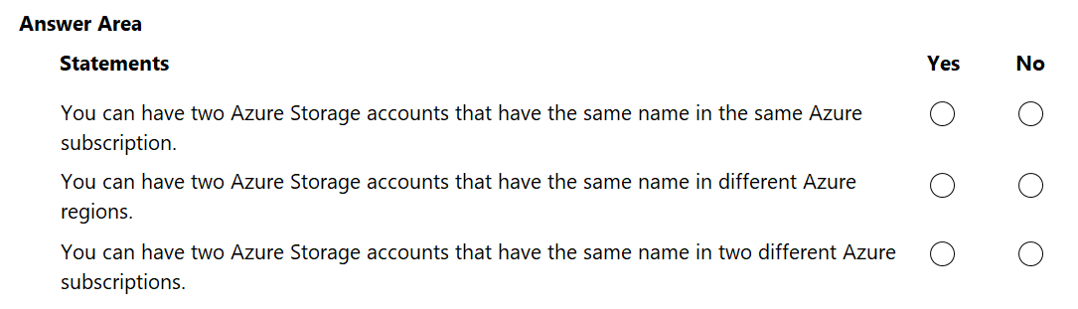
Answer:
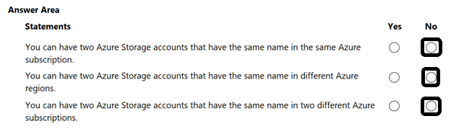

Question 418 Topic 1
HOTSPOT
-
For each of the following statements, select Yes if the statement is true. Otherwise, select No.
NOTE: Each correct selection is worth one point.
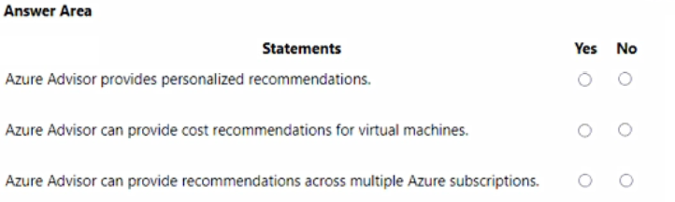
Answer:
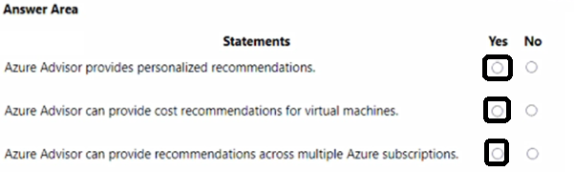

Question 419 Topic 1
HOTSPOT
-
For each of the following statements, select Yes if the statement is true. Otherwise, select No.
NOTE: Each correct selection is worth one point.
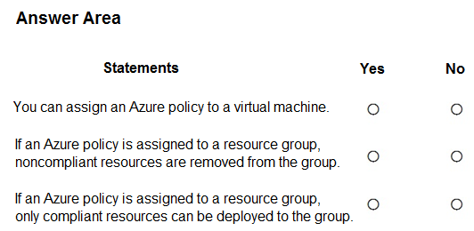
Answer:
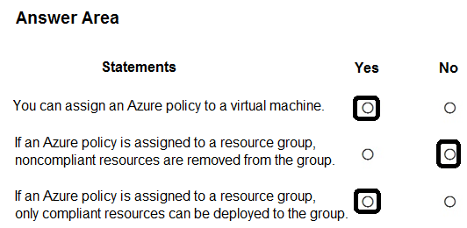

Question 420 Topic 1
You have on-premises servers that run Windows Server.
What should you implement to manage the servers by using the Azure portal?
A. Azure Kubernetes Service (AKS)
B. Azure Arc
C. Docker
D. role-based access control (RBAC)
Answer: B
Voted Answer: B

Question 421 Topic 1
HOTSPOT
-
Select the answer that correctly completes the sentence.
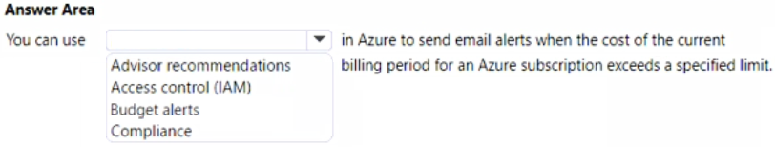
Answer:
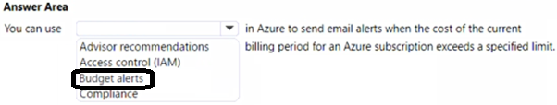

Question 422 Topic 1
HOTSPOT
-
Select the answer that correctly completes the sentence.
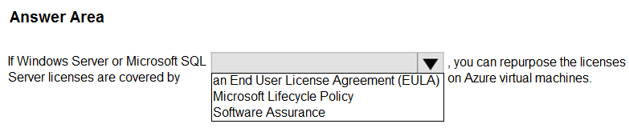
Answer:
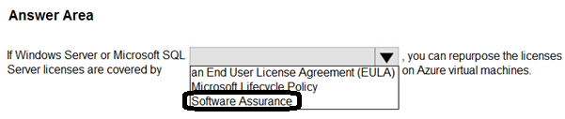

Question 423 Topic 1
You have a web app that runs in Azure.
You need to identify the amount of time it takes for web pages to load in a user's browser.
What should you use?
A. Azure Monitor alerts
B. Application Insights in Azure Monitor
C. Log Analytics
D. Azure Network Watcher
Answer: B
Voted Answer: B

Question 424 Topic 1
HOTSPOT
-
Select the answer that correctly completes the sentence.
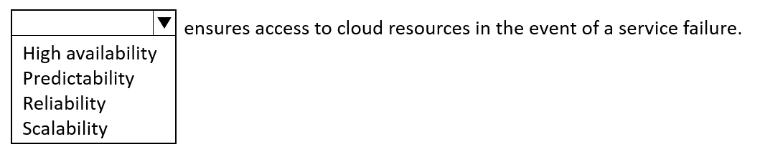
Answer:
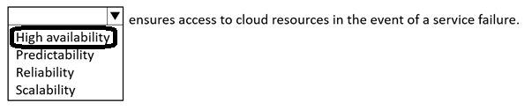

Question 425 Topic 1
What should a desktop application use to interact with Azure and manage resources?
A. APIs
B. Azure Resource Manager (ARM) templates
C. Azure Command-Line Interface (CLI)
D. Azure Cloud Shell
Answer: A
Voted Answer: B

Question 426 Topic 1
DRAG DROP
-
Match the cloud computing benefits to the appropriate requirements.
To answer, drag the appropriate benefit from the column on the left to its requirement on the right. Each benefit may be used once, more than once, or not at all.
NOTE: Each correct match is worth one point.
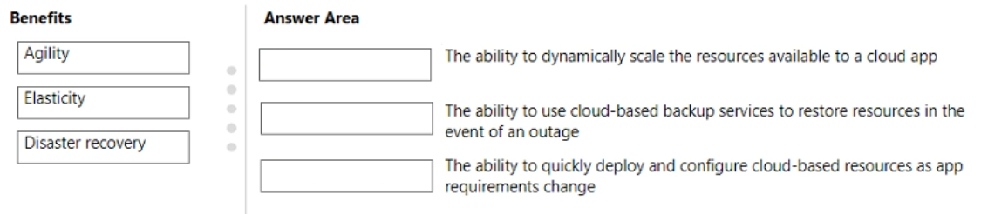
Answer:
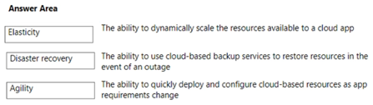

Question 427 Topic 1
DRAG DROP
-
Match the security components to the appropriate defense in depth layers.
To answer, drag the appropriate security component from the column on the left to its defense in depth layer on the right Each security component may be used once, more than once, or not at all.
NOTE: Each correct match is worth one point.
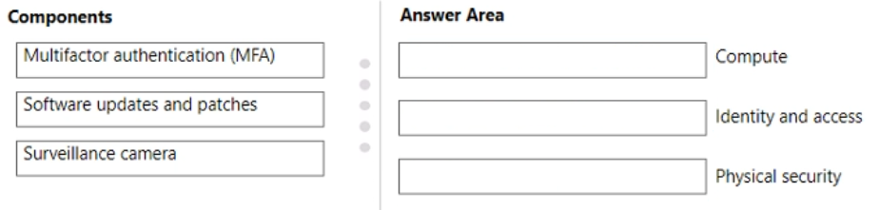
Answer:
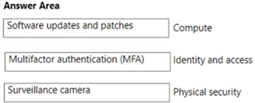

Question 428 Topic 1
HOTSPOT
-
For each of the following statements, select Yes if the statement is true. Otherwise, select No.
NOTE: Each correct selection is worth one point.
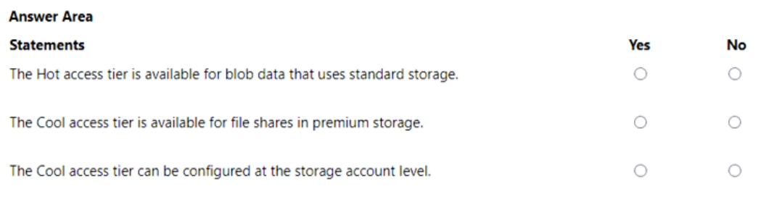
Answer:
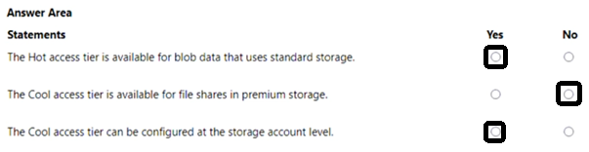

Question 429 Topic 1
Which two features or services can be integrated with Azure Monitor? Each correct answer presents part of the solution.
NOTE: Each correct answer is worth one point.
A. Azure status
B. Application Insights
C. Azure Advisor
D. Log Analytics
E. Azure Service Health
Answer: BD
Voted Answer: BD

Question 430 Topic 1
What provides a unified way to project and manage non-Azure resources in Azure Resource Manager (ARM)?
A. Azure Migrate
B. Azure AD Connect
C. Azure Arc
D. Azure Front Door
Answer: C
Voted Answer: C

Question 431 Topic 1
HOTSPOT
-
For each of the following statements, select Yes if the statement is true. Otherwise, select No.
NOTE: Each correct selection is worth one point.
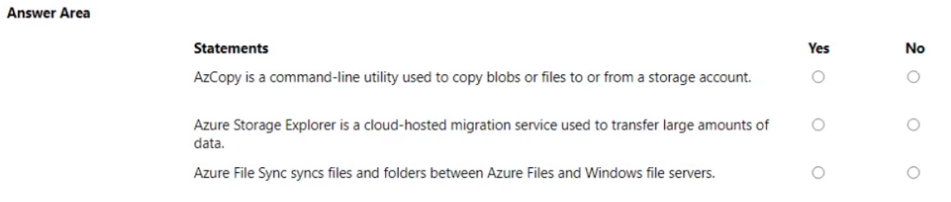
Answer:
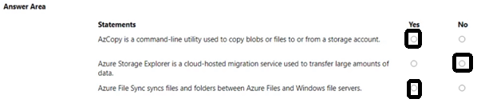

Question 432 Topic 1
HOTSPOT
-
Select the answer that correctly completes the sentence.
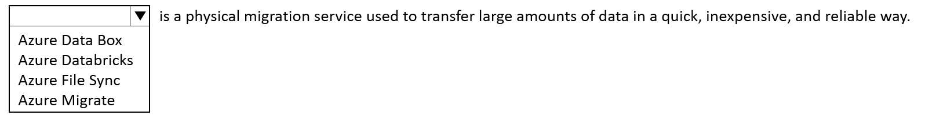
Answer:
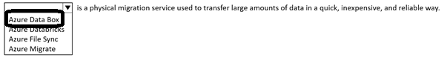

Question 433 Topic 1
Your company has an Azure subscription and three business units.
You plan to deploy new resources for each business unit.
You need to ensure that the new resources are deployed by using a repeatable and reliable method that applies the same configurations to each resource.
What should you use?
A. Azure Policy
B. Azure Arc
C. a resource group
D. Azure Resource Manager (ARM) templates
Answer: D
Voted Answer: D

Question 434 Topic 1
HOTSPOT
-
For each of the following statements, select Yes if the statement is true. Otherwise, select No.
NOTE: Each correct selection is worth one point.
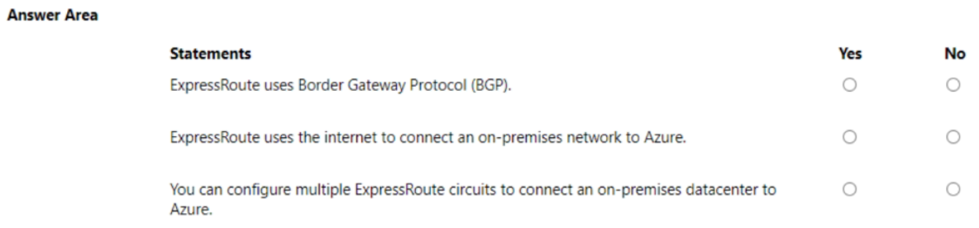
Answer:
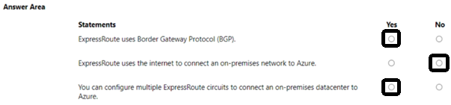

Question 435 Topic 1
HOTSPOT
-
For each of the following statements, select Yes if the statement is true. Otherwise, select No.
NOTE: Each correct selection is worth one point.
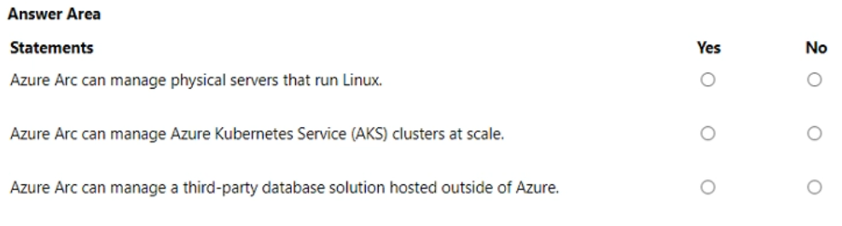
Answer:
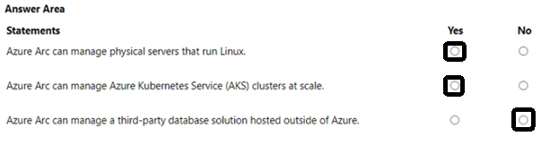

Question 436 Topic 1
HOTSPOT
-
Select the answer that correctly completes the sentence.
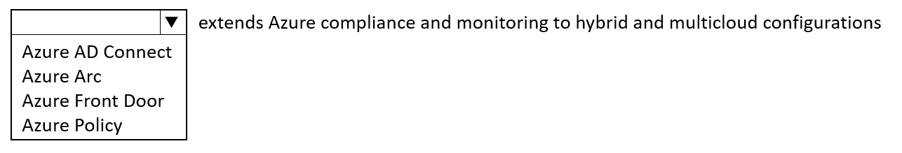
Answer:
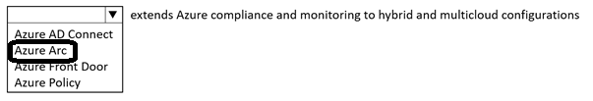

Question 437 Topic 1
In the software as a service (SaaS) cloud service, which responsibility is shared between Microsoft and the customer?
A. identity and directory infrastructure management
B. application management
C. information and data management
D. operating system updates
Answer: A
Voted Answer: A

Question 438 Topic 1
Where does Azure Monitor store event data?
A. an Azure Blob Storage account
B. Azure Storage Queue
C. Azure SQL Database
D. a Log Analytics workspace
Answer: D
Voted Answer: D

Question 439 Topic 1
HOTSPOT
-
Select the answer that correctly completes the sentence.
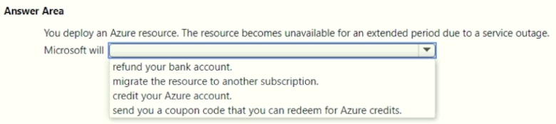
Answer:
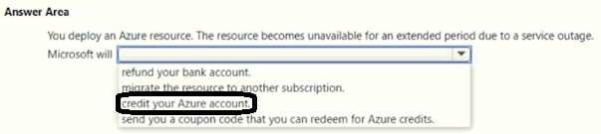

Question 440 Topic 1
HOTSPOT -
For each of the following statements, select Yes if the statement is true. Otherwise, select No.
NOTE: Each correct selection is worth one point.
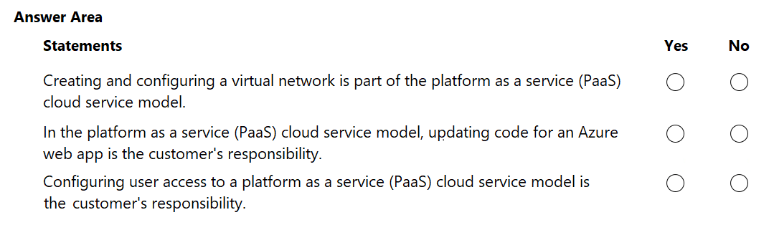
Answer:
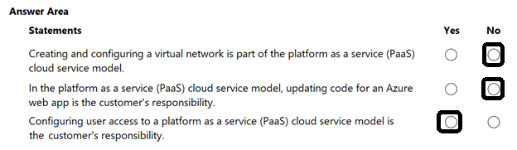

Question 441 Topic 1
HOTSPOT -
For each of the following statements, select Yes if the statement is true. Otherwise, select No.
NOTE: Each correct selection is worth one point.
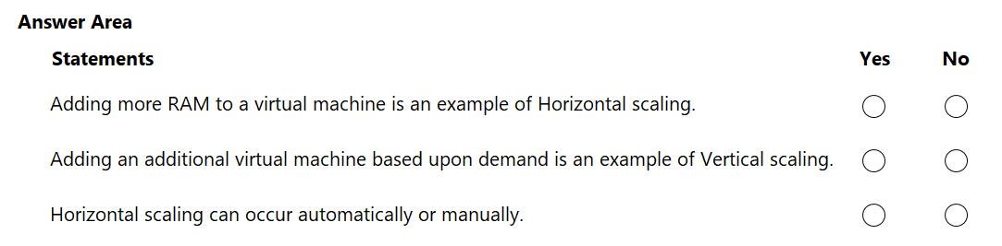
Answer:
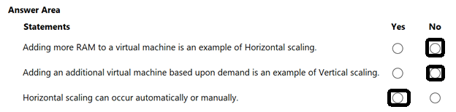

Question 442 Topic 1
You have an Azure subscription.
You need to use Azure Cloud Shell to run a deployment script.
What should you use to access Cloud Shell?
A. Azure Resource Manager (ARM)
B. Microsoft Visual Studio
C. a Windows command prompt
D. a web browser
Answer: D
Voted Answer: D

Question 443 Topic 1
An Azure administrator plans to run a PowerShell script that creates Azure resources.
You need to recommend which computer configuration to use to run the script.
Which three computers can run the script? Each correct answer presents a complete solution.
NOTE: Each correct selection is worth one point.
A. a computer that runs Windows 11 and has the Azure CLI tools installed
B. a computer that runs Linux and has the Azure CLI tools installed
C. a computer that runs macOS and has PowerShell Core 6.0 installed
D. a computer that runs Chrome OS and uses Azure Cloud Shell
E. a computer that runs Windows 10 and has the Azure PowerShell module installed
Answer: ADE
Voted Answer: ADE

Question 444 Topic 1
HOTSPOT
-
For each of the following statements, select Yes if the statement is true. Otherwise, select No.
NOTE: Each correct selection is worth one point.
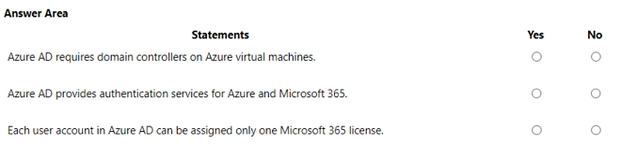
Answer:
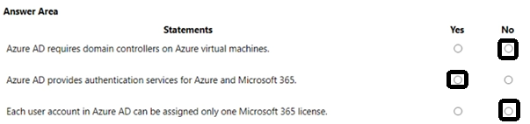

Question 445 Topic 1
In the infrastructure as a service (IaaS) cloud service model, which two components are the responsibility of the cloud service provider? Each correct answer presents a complete solution.
NOTE: Each correct selection is worth one point.
A. the configuration and maintenance of storage
B. the installation and configuration of the operating system
C. maintaining the hardware
D. the network configuration
E. physical security of the datacenter infrastructure
Answer: CE
Voted Answer: CE

Question 446 Topic 1
HOTSPOT
-
Select the answer that correctly completes the sentence.
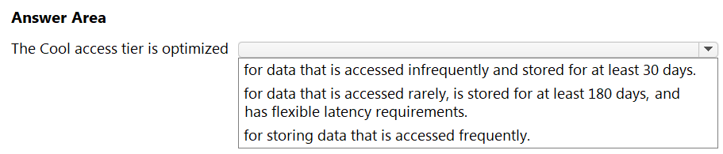
Answer:
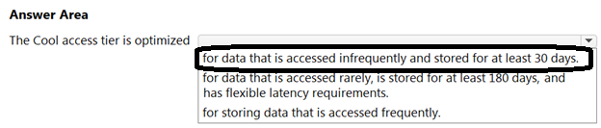

Question 447 Topic 1
HOTSPOT
-
Select the answer that correctly completes the sentence.
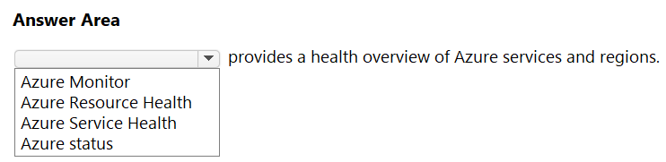
Answer:
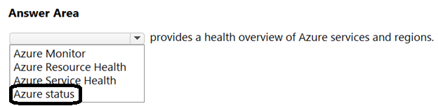

Question 448 Topic 1
HOTSPOT
-
For each of the following statements, select Yes if the statement is true. Otherwise, select No.
NOTE: Each correct selection is worth one point.
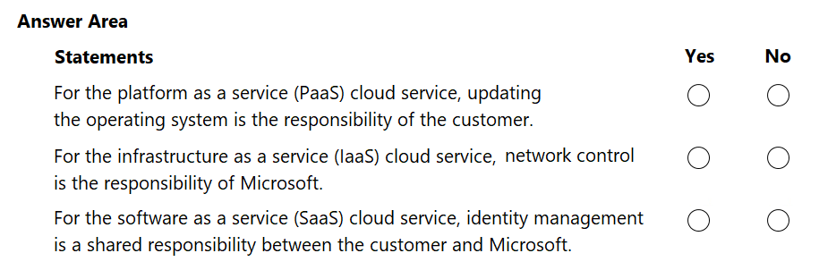
Answer:
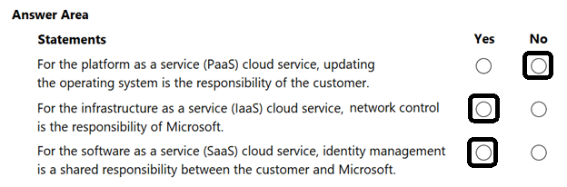

Question 449 Topic 1
HOTSPOT
-
Select the answer that correctly completes the sentence.
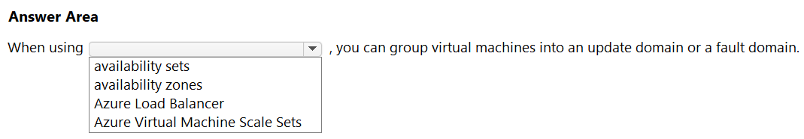
Answer:
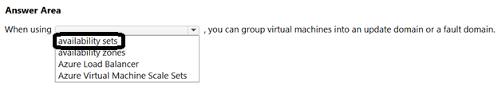

Question 450 Topic 1
You have an Azure Storage account named storage1.
You need to ensure that containers can be created in, but not deleted from, storage1.
What should you do?
A. Create a ReadOnly lock for storage1.
B. Create a delete lock for storage1.
C. Enable container soft delete.
D. Enable blob soft delete.
Answer: B
Voted Answer: B

Question 452 Topic 1
You have an Azure environment.
You need to create a new Azure virtual machine from a tablet that runs the Android operating system.
What are three possible solutions? Each correct answer presents a complete solution.
NOTE: Each correct selection is worth one point.
A. Use the Settings app.
B. Use the Azure portal.
C. Use Bash in Azure Cloud Shell.
D. Use the PowerApps portal.
E. Use PowerShell in Azure Cloud Shell.
Answer: BDE
Voted Answer: BCE

Question 453 Topic 1
HOTSPOT
-
For each of the following statements, select Yes if the statement is true. Otherwise, select No.
NOTE: Each correct selection is worth one point.
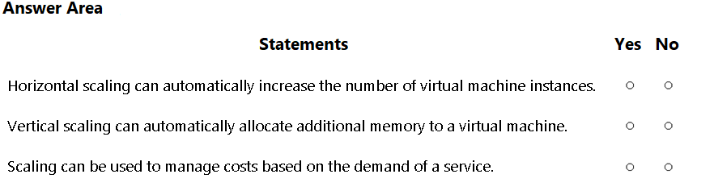
Answer:
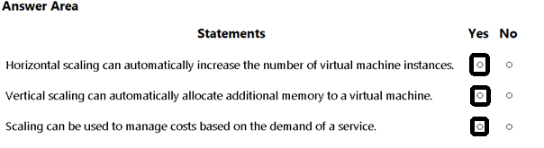

Question 454 Topic 1
HOTSPOT
-
For each of the following statements, select Yes if the statement is true. Otherwise, select No.
NOTE: Each correct selection is worth one point.
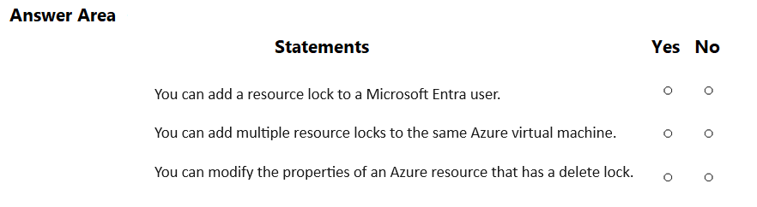
Answer:
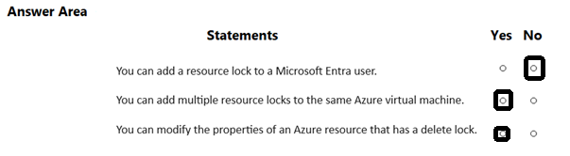

Question 455 Topic 1
You have an Azure subscription that contains a resource group named RG1.
Users must NOT be able to perform the following operations:
• Delete RG1.
• Modify resources in RG1.
• Delete resources from RG1.
What should you do?
A. Apply a delete lock to RG1.
B. Apply a read-only lock to RG1.
C. Grant role-based access control (RBAC) permissions to RG1.
D. Add a tag to RG1.
Answer: B

Question 457 Topic 1
To which type of cloud service can you install an operating system?
A. infrastructure as a service (IaaS) only
B. platform as a service (PaaS) only
C. software as a service (SaaS) only
D. infrastructure as a service (IaaS) and platform as a service (PaaS) only
E. platform as a service (PaaS) and software as a service (SaaS) only
Answer: A

Question 458 Topic 1
HOTSPOT
-
Select the answer that correctly completes the sentence.
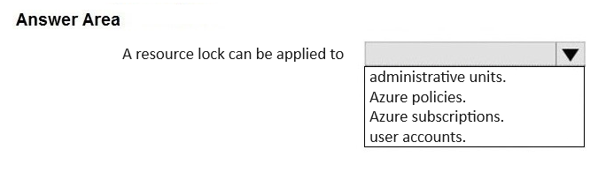
Answer:
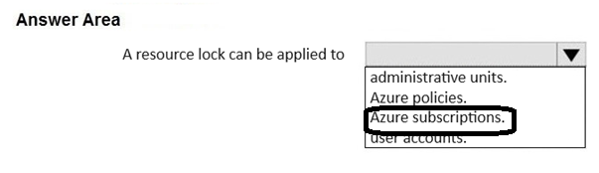

Question 459 Topic 1
HOTSPOT
-
Select the answer that correctly completes the sentence.
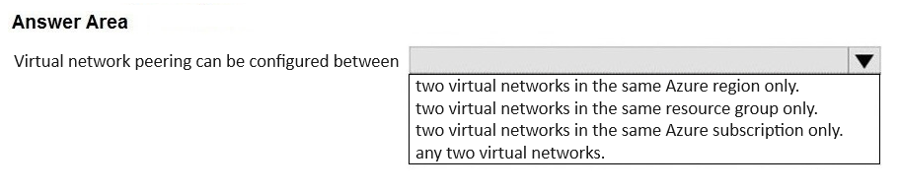
Answer:
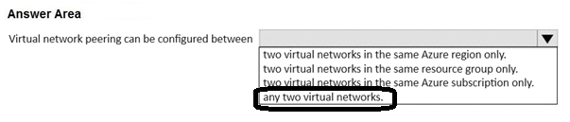

Question 461 Topic 1
DRAG DROP
-
Match the Azure compute services to the appropriate descriptions.
To answer, drag the appropriate compute service from the column on the left to its description on the right. Each service may be used once, more than once, or not at all.
NOTE: Each correct match is worth one point.
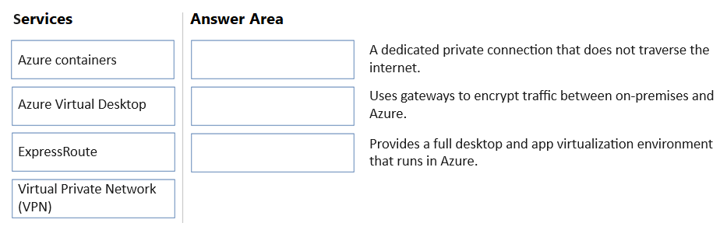
Answer:
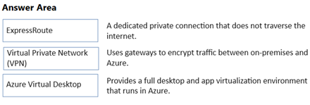

Question 462 Topic 1
HOTSPOT
-
For each of the following statements, select Yes if the statement is true. Otherwise, select No.
NOTE: Each correct selection is worth one point.
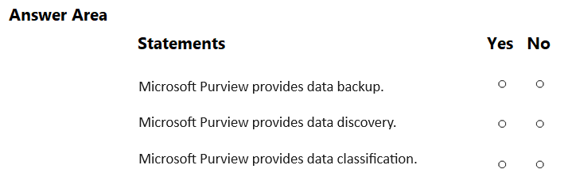
Answer:
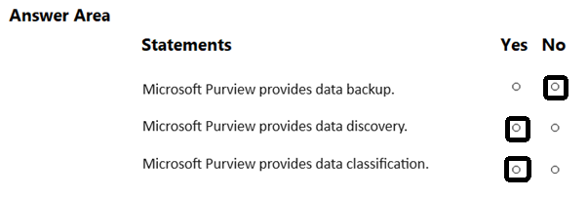

Question 463 Topic 1
HOTSPOT
-
For each of the following statements, select Yes if the statement is true. Otherwise, select No.
NOTE: Each correct selection is worth one point.
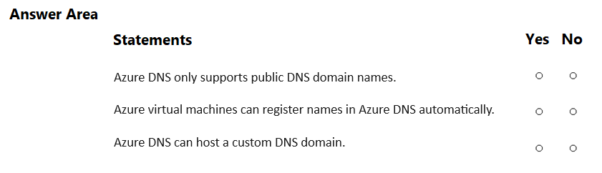
Answer:
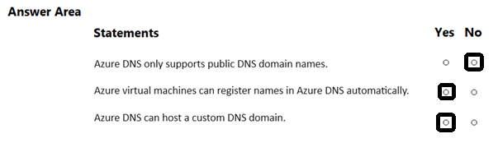

Question 464 Topic 1
HOTSPOT
-
You need to identify which blades in the Azure portal must be used to perform the following tasks:
• View security recommendations.
• Monitor the health of Azure services.
Which blade should you identify for each task? To answer, select the appropriate options in the answer area.
NOTE: Each correct selection is worth one point.
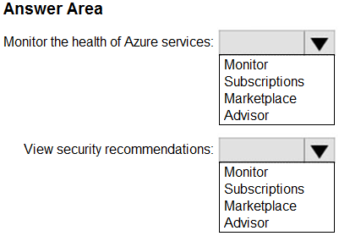
Answer:
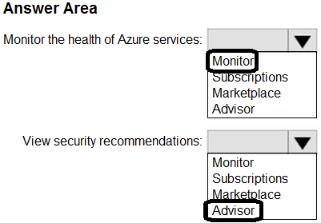

Question 465 Topic 1
HOTSPOT
-
For each of the following statements, select Yes if the statement is true. Otherwise, select No.
NOTE: Each correct selection is worth one point.
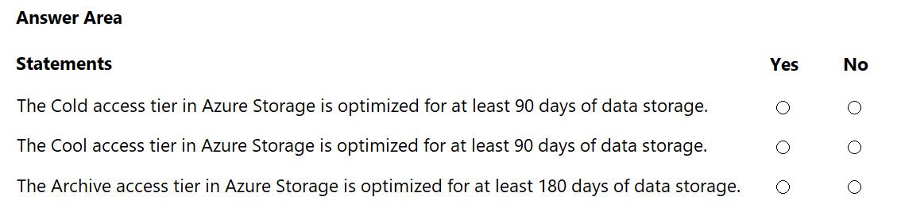
Answer:
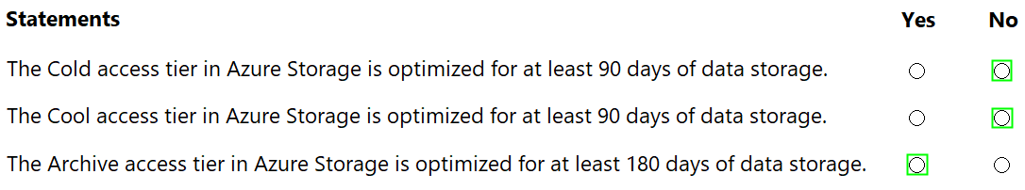

Question 466 Topic 1
HOTSPOT
-
Select the answer that correctly completes the sentence.
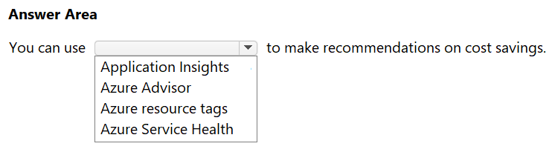
Answer:
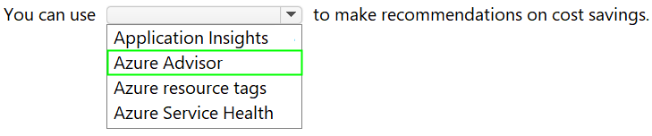

Question 467 Topic 1
DRAG DROP
-
In which order should you arrange the Azure resources from the highest parent object (top) to the lowest child object? To answer, move all resources from the list of resources to the answer area and arrange them in the correct order.
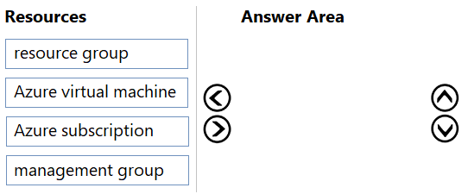
Answer:
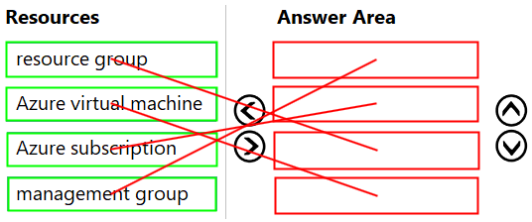

Question 468 Topic 1
HOTSPOT
-
For each of the following statements, select Yes if the statement is true. Otherwise, select No.
NOTE: Each correct selection is worth one point.
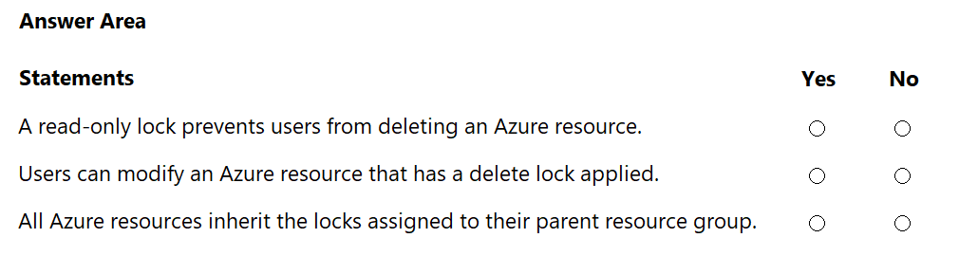
Answer:
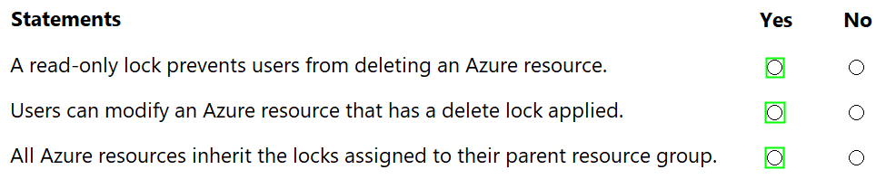

Question 469 Topic 1
DRAG DROP
-
Match the authentication method to the appropriate level of security.
To answer, drag the appropriate authentication method from the column on the left to its level of security on the right.
NOTE: Each correct match is worth one point.
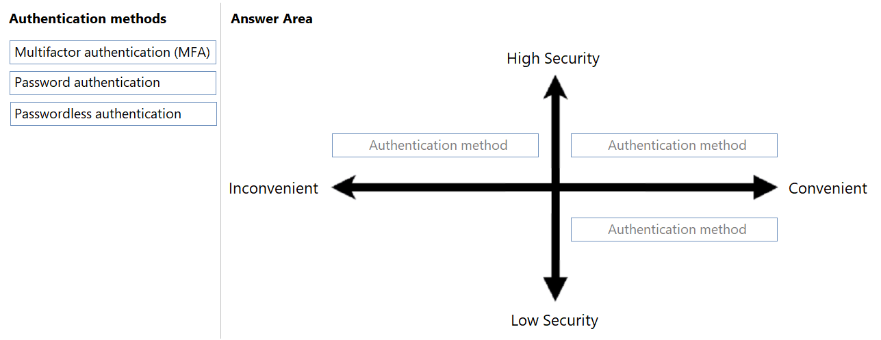
Answer:
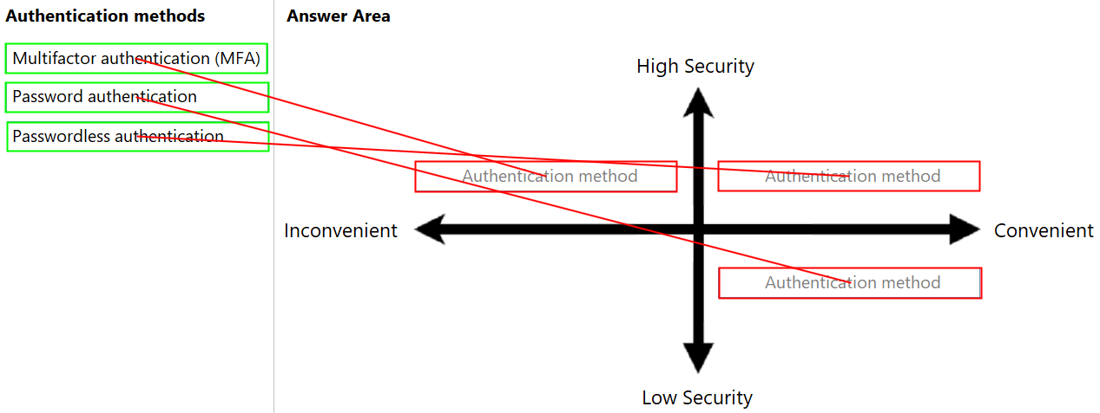

Question 470 Topic 1
How many data copies are stored in gee-zone-redundant storage (GZRS)?
A. 2
B. 3
C. 6
D. 12
Answer: C
Voted Answer: C

Question 471 Topic 1
HOTSPOT
-
Select the answer that correctly completes the sentence.
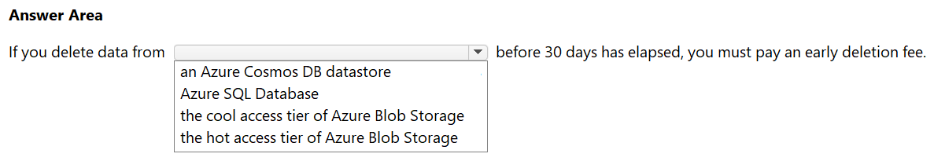
Answer:
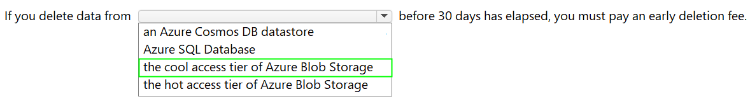

Question 472 Topic 1
DRAG DROP
-
Match the cloud service to the appropriate description.
To answer, drag the appropriate cloud service from the column on the left to its description on the right. Each service may be used once, more than once, or not at all.
NOTE: Each correct match is worth one point.
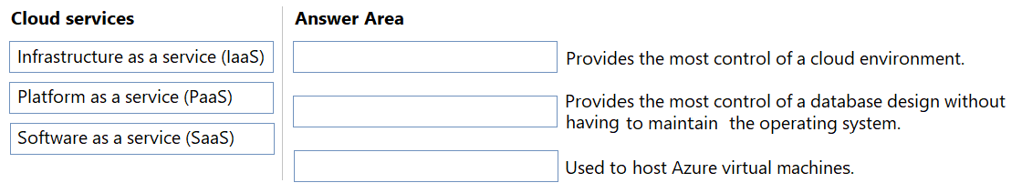
Answer:
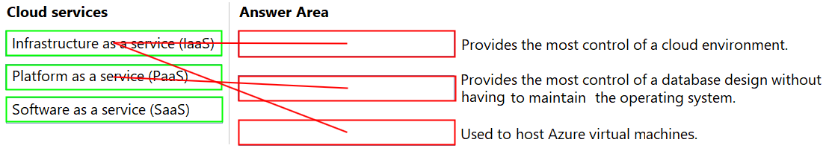

Question 474 Topic 1
What can you use to make recommendations that will reduce Azure costs?
A. Azure Advisor
B. Log Analytics
C. Azure Service Health
D. the Azure pricing calculator
Answer: A
Voted Answer: A

